

**Managing global finance as a system**

Speech given by

Andrew G Haldane, Chief Economist, Bank of England

At the Maxwell Fry Annual Global Finance Lecture, Birmingham University 29 October 2014

The views are not necessarily those of the Bank of England or the Monetary Policy Committee. I would like to thank Ambrogio Cesa-Bianchi, Edd Denbee, Jeremy Franklin, Carsten Jung, Matt Roberts-Sklar,

Stephanie Quiet and Benedict Roth for assistance in preparing the text. I would also like to thank to Rob Elder, Jeremy Harrison, Kristin Forbes, James Smith and Stacy Williams (HSBC FX Quantitative Strategy Team) for insights and comments.

1

All speeches are available online at [www.bankofengland.co.uk/publications/Pages/speeches/default.aspx](http://www.bankofengland.co.uk/publications/Pages/speeches/default.aspx)

It is a great honour to be giving this year’s Maxwell Fry Global Finance Lecture. Max was a tremendous colleague, both during his time here at Birmingham University and as Director of the Centre for Central Banking Studies at the Bank of England.

Max also had a rare gift. Through his exceptionally rich academic and public policy career, he was able to integrate the insights from disciplines which all too rarely communicated – monetary theory and central bank practice, advanced and emerging market experience, financial markets dynamics and mainstream

macro-economics.

The global financial crisis could not have provided a clearer demonstration of the benefits of combining these insights. Without them, it would have been impossible to make sense of the chaotic dynamics of global economies and financial systems at the time. In other words, nothing could have provided a better case study of the importance of Max’s work than the crisis.

And it is lessons from the global financial crisis with which I want to begin. These are of course many and varied. But among the most important is also perhaps the simplest: to safeguard against systemic risk, the financial system needs to be managed as *a system* (Haldane (2009)). As put, this statement seems rather obvious, perhaps even tautological.

Yet, pre-crisis, it was far from obvious. The orthodoxy then was that safeguarding individual financial firms was a necessary and sufficient condition for system-wide stability. This was the financial stability equivalent of the English aphorism: “look after the pennies and the pounds will look after themselves”. And so it appeared during the long pre-crisis period of stable growth and stable banks - the “Great Moderation” (Bernanke (2004)).

The crisis has rewritten that orthodoxy. It revealed that the safety of individual banks was neither a necessary nor sufficient condition for systemic stability. Not necessary because, in any well-functioning system, individual banks can and should fail. Not sufficient because, in an integrated web, the chain is only as strong as its weakest link.

In focussing on individual banks, policymakers had been, to coin another English aphorism, “penny-wise but pound-foolish”. That is why Great Moderation gave way to Great Recession (Gai and Kapadia (2010)). That is why systemic risk entered the public lexicon. And that is why financial regulation has, in the period since, been fundamentally re-oriented towards the monitoring and management of systemic risk.

Interestingly, that lesson would have come as no surprise to anyone familiar with dynamic, integrated networks *outside* of the world of finance. Assessing the stability of almost any network known to man – whether natural, physical, social or economic – relies upon a system-wide assessment. And protection mechanisms for this system need to be calibrated to system-wide characteristics (Goldin and Mariathasan (2014)). Financial webs are no exception. The history of financial crises suggests they may be closer to the rule.

This new orthodoxy has framed the post-crisis regulatory reform agenda. It is why so-called macro-prudential policy has risen in prominence. It is why the world’s most inter-connected banks will in future be required to run with extra capital and liquidity. It is why OTC derivatives will in future be centrally traded and cleared. And it is why resolution of the world’s largest, cross-border banks has become such a priority. For the global banking system we now have a blueprint, an emerging new set of international rules of the road.

Yet if instead of banks we consider the financial fortunes of countries; if instead of inter-bank exposures we consider cross-border flows of capital; and if instead of international banking regulation we consider the international monetary system, it is far from clear that lessons have been learned, much less that the international rules of that road have been reformed.

Arguably, the rules of the road for this system have failed to keep pace with the growing scale and complexity of global financial flows. It is for this reason that some have called the international monetary system a

“non-system” or “anti-system” (Truman (2012) and De Larosiere (2014)) - a system whose shape and scale has outgrown its architecture.

I want to discuss these developments and their public policy implications. I first discuss the historical evolution of the international monetary network, including the remarkable recent surge in financial globalisation. I then discuss why financial globalisation can be double-edged from a stability perspective. Finally, I consider steps to strengthen the international architecture, to better manage global finance as a system.

# The historical evolution in global finance

It is fascinating to track how global financial integration has evolved over the past century. One way of gauging that is by looking at measured stocks of external asset and liabilities - the cumulative consequences of past cross-border capital flows (and valuation changes). Charts 1 and 2 plot world gross external assets, measured relative to world GDP, over the past 140 years. As a comparison, world trade relative to world GDP is also shown.

Global integration of trade and finance has followed roughly similar patterns. Both rose prior to World War I during the heyday of the classical Gold Standard, when trade and capital liberalisation were last at their peak. Both then fell during the interwar years, as national protectionism led to trade and financial barriers being erected. Then, from around 1960 onwards, trade and finance once more began to rise due to the lifting of restrictions on cross-border trade and capital flows (Broadbent (2014)).

Despite this close historical correlation, the undulations in global finance are far greater than those in world trade. In 1960, global finance was around one third of its value in 1914, measured relative to world GDP. By 2010, it had risen to three times its value in 1914. Put differently, in 1980 global trade and global finance were on a

broadly equal footing, at around a quarter of world GDP. By 2010, global finance was nine times global trade. At the same time world trade has flat-lined, global finance has come of age.

Today, cross-border stocks of capital are almost certainly larger than at any time in human history. We have hit a new high-water mark. The same is probably true of cross-border flows of goods and services and is most certainly true of cross-border flows of information (Haldane (2013)). We are accustomed to talking of the information technology revolution. Yet the revolution in global finance has in some respects been every bit as striking.

While these trends tell us something about *relative* patterns of global interconnection, they leave unanswered the question of whether global finance is a truly integrated network. To gauge that, consider an alternative measure of global capital market integration – the correlation between national saving and investment rates. From Feldstein and Horioka (1980), we know that this correlation provides a proxy for capital market integration.

For example, a savings/investment correlation of one indicates a closed capital account: all domestic investment needs to be fully financed from domestic saving. At a global level, this would signify something close to global financial autarky. By contrast, a correlation of zero implies that domestic investment can be fully financed on global capital markets. This would signal something close to perfect capital market integration. So saving/investment correlations of zero and one define the outer limits of global capital market integration.

Chart 3 plots this correlation coefficient over the same 140-year period shown in Chart 1. Broadly-speaking, the two series track one another fairly closely. But Chart 3 now allows us to say things about the *absolute* degree of capital market integration. And what a roller-coaster ride it has been. During the first period, from around 1880 up until the Great Depression, global financial integration sat roughly mid-way between its outer limits. Integration was high-ish, but far from perfect.

For around a fifty year period, from the 1930s through to the 1980s, global finance then went into hibernation. The Feldstein/Horioka coefficient skirted one for large parts of this period. The global financial system operated as anything but a system. Indeed, it was this which prompted Feldstein and Horioka in the early 1980s to present the “puzzle” of still-low levels of capital market integration.

Yet at pretty much precisely the point this puzzle was being identified, it began to disappear. Correlations quickly moved from close to unity in the early 1980s to close to zero by the start of the 21st century. This was an astonishingly rapid evolution from a world close to financial autarky to one close to financial nirvana. In the light of the crisis, measured levels of global capital market integration have fallen somewhat. But they remain at higher levels than at any point in history.

Overall, then, the picture is clear. For much of the 20th century, global finance was more patchwork than network. But the past thirty years have seen that picture change spectacularly. Today, global finance is a well-connected network, a tightly-woven and tangled web, a genuine system.

# The double-edged nature of financial integration

So what are the implications of this increase in global financial integration? There have been large numbers of studies exploring the growth and welfare implications of these trends, using cross-country and time-series evidence (Rey (2013)). This evidence paints, at best, a mixed picture. While capital integration ought to enhance international risk-sharing, there is surprisingly little evidence of this having conferred macro-economic benefits – and some of it having imposed costs.

For some economists, this is a perplexing and contentious conclusion. It is made all the more so by the fact that the evidence on global trade integration points overwhelmingly towards positive effects (Kose et al (2009) and Berg and Krueger (2003)). Yet, outside of economics and finance, this conclusion would be far less perplexing and contentious.

For many other disciplines, it is well-known that the increased integration of a network can be double-edged from a stability perspective (Watts (2002), Haldane and May (2011)): whether it is physical networks, like utility grids; or natural networks, like eco-systems; or social networks, like the world wide web. The logic is straightforward.

Within limits, connectivity acts as a shock-absorber. Links in the system act as a mutual insurance device, helping distribute and disperse risk. These systems are then “robust” to shocks. But when shocks are sufficiently large, connectivity may instead serve as a shock-transmitter. Risk-sharing becomes risk-spreading. Links in the system act as a mutual incendiary device, amplifying risk. These systems are then also “fragile”.

So connected systems tend simultaneously to be both stable and unstable, calm and turbulent, robust-yet-fragile (Acemoglu et al (2013), Gai and Kapadia (2010)). In other words, integration can be double-edged. It generates a world with instances of more frequent and/or larger dislocations. In short, what is true of natural, physical and social systems is also true of global economic and financial systems.

To illustrate that, consider Chart 4. This shows the results of a simulation of a hypothetical financial network of firms. These have differing levels of financial strength, measured on the x-axis. Think of this as a country’s level of official reserves or a bank’s level of liquid assets. On the z-axis is a measure of network interconnectivity – the scale of cross-border assets or interbank exposures. Finally, on the y-axis is a measure of systemic risk – the incidence of default across the network, whether of countries or banks.

As the network becomes better integrated, for a given degree of financial strength, systemic risk remains low. We operate in a zone of systemic stability. That is because the network is operating as a shock-absorber, a network insurance device scattering risk to the four corners. So it was pre-crisis.

But for a large-enough shock to financial strength, the system fundamentally changes shape. The network flips to a zone of systemic instability. That is because it is now operating as a shock-transmitter, a network incendiary device - and the greater the degree of integration, the sharper this knife-edge. So it was during the crisis.

This is the robust-yet-fragile property of connected webs. The global financial crisis provided no better example. The flat earth that was the Great Moderation gave way to the fragile planet that was the Great Recession.

Risk-sharing gave way to risk spreading, risk distribution to risk contagion.

This was by no means an isolated incident. Chart 5 plots a measure of global capital market integration (external assets/GDP) against a measure of the incidence of crises – all crises and banking crises (Reinhart and Rogoff (2011)). Integration appears to have been associated with an increase in the incidence of crisis over the past couple of decades, perhaps especially banking crises.

It is not just the incidence, but also the prospective size of crises and their spill-over consequences that has increased. Chart 6 provides one perspective on that. It looks at the scale of IMF programmes over time, normalised by the borrowing country’s quota. Two features are striking: first, the increased incidence of programmes; but second, more dramatically, their increased scale.

Academic evidence has long pointed towards important spillover effects from national or international disturbances (Obstfeld and Rogoff (1995), Forbes and Warnock (2012) and Fratzscher (2012)). But recent evidence points towards more potent contagion channels. For example, Rey (2013) finds evidence that a common global risk factor drives asset prices and cross-border capital flows, for both advanced and emerging economies.

It is worth putting under the microscope these shifting patterns in global financial market correlations, especially over the most recent period. Charts 7-9 plot correlations between long-term bond yields, equity prices and investment grade corporate bond spreads respectively in the US, UK and the euro-area over the past few decades. Two features stand out.

First, there has been a steady rise in the degree of co-movement in asset prices over time. Take government bond yields over the past 50 years. Over the first quarter century, from 1960 through to the mid-1980s, average pairwise correlations between bond yields were around 0.1. Over the subsequent quarter-century, these correlations have risen steadily, averaging 0.7 over the latter part of the sample (Chart 7).

Second, and more striking still, is the level reached by these correlation coefficients towards the end of the sample. Whether it is safe government assets or risky corporate bonds and equities, correlations typically lie in the range 0.7 to 0.9. Other things equal, a common global factor potentially accounts for perhaps 70-90% of the movements in advanced country asset prices.

These correlation patterns are stronger, and even more striking, when we look at their evolution over time. As one example of that, Charts 10 and 11 plot “heatmaps” of the strength of a common factor in the variation of spot and forward rates respectively for government bonds at different maturities in the UK, US and Germany over the period since 1995.

In general, they show the same pattern of high and rising correlations over time. But these correlations also show distinctive flare-ups, associated with spasms in global financial markets such as the global financial crisis and last year’s ‘taper tantrum’. By the end of the sample almost the whole of the yield curve, bar the very short end, is moving synchronously across countries. To a first approximation, global yield curves appear these days to be dancing to a common tune.

All of this evidence points in one direction: the global monetary system operates in a similar fashion to all other tightly-knit networks – it is robust yet at the same time fragile. It is driven by potent – increasingly potent – spillover effects and common global factors. In short, global finance can only be understood and managed as a system.

# Characteristics of the global financial network

The next obvious question is what mechanisms are in place to underpin the resilience of this tightly-woven web? Let me highlight some key characteristics of the global financial network which are useful in assessing its robustness. And let’s start with the good news.

One positive trend in the international flow of funds is their changing composition. Table 1 breaks down these flows of funds into their foreign direct investment (FDI), portfolio and debt components, for advanced and emerging markets, over the periods 1980-1994 and 1995-2012. Two features stand out.

First, the declining share of debt-based finance and second, as the counterpart to this, the rising share of portfolio and in particular FDI investment. For example, since 1995 the dominant source of emerging market capital has switched dramatically from debt-based finance towards FDI. Equity and FDI together now account for two-thirds of emerging market financing.

That is significant from a stability perspective. Empirical evidence strongly suggests that FDI and, to a lesser extent, equity is a far more stable source of external financing than bank debt (Kose et al (2009)).1 That is in part

1 Bank of England research adds one nuance to this story. Dell’Erba and Reinhardt (2013) find that financial sector FDI appears to behave more like debt flows than traditional FDI flows.

because of its longer duration and in part because of its superior risk-sharing properties. For at least some emerging markets, their national balance sheets appear to be moving to a more robust footing.

A second positive development comes from looking at countries’ degree of self-insurance, in particular their stock of foreign exchange reserves. As Chart 12 shows, these have grown dramatically since the second world war and especially since the Asian crisis, both in money terms and relative to world GDP. Reserves have risen from

$1.5 trillion in 1995 to over $11 trillion by end-2013, or from around 5% of world GDP to around 15% today.

Third, this has been accompanied by some augmentation of multilateral official sector facilities for helping handle external financing shocks. For example, since 1980 IMF quota resources have risen from just under $80 billion to around $370 billion, or from 0.7% to just less than 2% of world GDP (Chart 13). The most significant augmentation in resources came from the New Arrangements to Borrow (NAB) in 2009, which were agreed to increase temporarily the resources available to the IMF at the height of the financial crisis.

Fourth, alongside these multilateral facilities, the past few years have seen rapid growth in regional and bilateral financing facilities (Chart 14). Regionally, we now have a number of financing arrangements, including the Chiang Mai initiative in Asia (established in 2000), the European Stability Mechanism (established in 2012), the Latin American Reserve Fund (established in 1991), the Arab Monetary Fund (established in 1976) and, most recently, the BRICS development bank (established in 2014)). Regional facilities now total around $1.3 trillion.

In addition, during the course of the crisis, bilateral foreign currency swap lines were agreed between around

14 central banks, in both advanced and emerging market countries. Although these swap lines were temporary, in October 2013 they were replaced by a set of permanent, and potentially unlimited, swap lines among a group of advanced economy central banks: the US, Canada, the UK, the euro-area, Switzerland and Japan.

These four developments, in combination, are likely to have increased significantly the potential pool of liquidity insurance available to the global financial system in dealing with external financing shocks. The question is whether this degree of insurance has kept pace with the accompanying rising tide of global capital market integration.

One metric for that is found by scaling countries’ foreign exchange reserves by a measure of financial globalisation – for example, total external assets (Chart 15). Despite the rapid rise in reserves, its ratio to external asset stocks has actually fallen since 1980, from 10% to around 8%.

Second, official reserves have risen unevenly across countries: the degree of concentration in reserves has increased threefold since 2000. Moreover, those countries most at risk from capital flight are not necessarily those with the highest reserves. Scaling countries’ reserves by measures of their external short-term indebtedness suggests a highly-uneven pattern (Chart 16), with a number of countries holding less than would be needed to meet a year’s worth of capital outflows.

Third, this pattern is broadly mirrored when moving from measures of self-insurance, such as reserves, to official financing measures. Chart 17 scales IMF resources by external assets. Since the 1980s, this measure has roughly halved from 3% to 1.5%. And fourth, even once we augment multilateral financing with measures of regional official financing, total official resources relative to external assets are still shy of their levels in 1980.

Taken in combination, this paints a picture of an international monetary system whose underlying topology has fundamentally changed shape and scale – much larger, much more connected. But it is also a system whose architecture may have failed to keep pace with those changes. Therein lies a key potential fault-line.

# Strengthening the system

This naturally begs the question - what might be done to close this fault-line, to improve the resilience of the international monetary system? One response would be to retreat from financial globalisation by re-imposing barriers to capital movement, unravelling the tightly-woven knitting of the global financial web. We have seen this movie before. It opened in the aftermath of the Great Depression and ended in disaster.

There should be better ways of making financial globalisation work, while guarding against its darkest consequences – to achieve robustness without fragility. But this may require new tools and approaches, operating system-wide. It may even require a new architecture, strong enough to withstand the new scale and scope of systemic risks.

Let me discuss four areas where progress could realistically be made in developing this new architecture: *financial surveillance*; *debt structures*; *macro-prudential policies*; and *multilateral financing*. Each would be an important new brick in the wall.

1. *Improvements to global financial surveillance*

Forewarned is forearmed. Understanding the dynamics of the international monetary system, its tipping points and edges, is a pre-requisite for effective management. Some progress has been made on this front. For example, the IMF’s *Global Financial Stability Report* has, since 2002, sought to plot the evolving contours of global finance. And the publication by the IMF of “Spillover Reports”, since 2011, is a further step in the right direction.

Nonetheless, these steps only take us so far. The centrepiece of the IMF’s surveillance efforts remain the country-specific Article IV consultations. Whether that country-specific focus, enshrined in the IMF’s 1944 Articles, can be justified in today’s highly integrated global financial network is a more open question. This year’s IMF *Triennial Surveillance Review* may be an opportunity to tilt the balance further towards multilateral surveillance.

What more might be feasible? I have a dream. It is futuristic, but realistic. It involves a Star Trek chair and a bank of monitors. It would involve tracking the global flow of funds in close to real time (from a Star Trek chair using a bank of monitors), in much the same way as happens with global weather systems and global internet traffic (Haldane (2011)). Its centre piece would be a global map of financial flows, charting spill-overs and correlations.

Such a global financial surveillance system could serve a number of policy ends. It would allow policymakers to monitor the evolution of the financial system in real time, as it expanded, contracted and changed shape. It would also allow them to simulate and stress-test this system to help detect impending financial cliff-edges. The IMF would be the natural guardian of this global-financial-map-cum-stress-testing-machine.

To give this concept some (literal and metaphorical) colour, Chart 18 shows a bank of heatmaps of correlations across a wide range of assets (safe and risky) and a large set of countries (advanced and emerging). There are shown at three dates – a pre-crisis period of calm, the Lehmans Brothers crisis of 2008 and at present. These correlations are grouped in two ways, by asset class and by country.

The correlation matrix broadly matches the patterns from the earlier heatmaps. Temperatures appear to be rising over time, with flare-ups at times of crisis. With this map now encompassing a wider range of assets and countries, the strength of these correlations underscores the genuinely global nature of today’s international financial system.

But there is a second, more striking pattern which emerges when these correlations are grouped by asset class and by country. Correlations are far higher by asset class than by country. In other words, there is greater

co-movement among similar asset types *across* countries than among different asset types *within* countries. A portfolio-level cut is more revealing about the underlying dynamics of global finance than a country-specific cut.

How to make sense of these patterns? One explanation may lie in the behaviour of global asset managers. Financial markets are increasingly driven by their behaviour (IMF (2014)). For asset managers, the key determinants of their portfolio choice may be the risk characteristics of different asset classes, rather than their country characteristics. Certainly, that is consistent with the correlation patterns.

Either way, these patterns serve to underline the importance of multilateral and spillover-based analysis, as distinct from country-specific (Article IV) surveillance, when assessing risks to both global and national financial systems. They also carry potentially important implications for how these dynamics might most effectively be managed from a macro-prudential perspective (discussed below).

1. *Improvements to country debt structures (and restructures)*

Debt flows are known to be a potent source of instability within the international monetary system. The instabilities they generate are exacerbated by frictions in the design of debt contracts. One such friction is that debt is an inherently pro-cyclical instrument. For example, a negative shock to a country’s income prospects will tend to raise debt sustainability concerns and hence borrowing costs, thereby worsening sustainability.

Another friction is that, once internationally-held debt becomes unsustainable, restructuring it is usually a messy process because of the lack of an internationally-agreed legal framework. In part for that reason, countries have tended to delay tackling unsustainable debt. But if debt is truly unsustainable, delay tends to further worsen debt dynamics, ultimately increasing costs for both debtors and creditors (Krugman (1988)).

These contractual frictions can make debt a fickle friend. They will tend to aggravate debt sustainability and debtor prevarication problems, thereby encouraging investors to withdraw credit at the first sign of

trouble – so-called “sudden stops” (Calvo (1998)). These frictions are well-illustrated by historical sovereign debt restructuring experience, most recently in emerging market economies such as Argentina.

Yet it is widely accepted that there are straightforward contractual solutions to these debt problems. One is to issue debt instruments whose contractual features reduce pro-cyclicality, such as GDP-linked bonds. Their repayment profile adjusts with a country’s ability to pay, thereby acting counter-cyclically and quasi-automatically to defuse repayment risk (Shiller (1993 and 2003), Barr et al (2014)).

The impact of such instruments on debt dynamics could be significant. A recent Bank of England study considered the debt-to-income ratios of the G7 countries, given shocks to growth and real interest rates, comparing conventional and GDP-linked debt. The latter cut the variability of G7 debt-to-income ratios in half. Yet despite their attraction, no more than a handful of countries internationally have so far issued GDP-linked debt instruments.

Contingent convertible (“CoCo”) bonds are a second, potentially useful, debt instrument. These have been popular recently among banks. For countries, they could be designed with a duration which is automatically extended if a country breaches certain pre-set stress conditions – for example, if it is the subject of an IMF lending programme (Brooke et al (2012)). This would then deliver some automatic alleviation of short-term liquidity pressures. So far, no country has issued such instruments.

There has been somewhat greater progress towards the inclusion of contractual clauses which assist in the restructuring of sovereign debts once these become unsustainable. In particular, following the Asian crisis there was a push by the international community to include Collective Action Clauses (CACs) in international bond contracts.

Yet as recent Argentine experience illustrates, this has not closed the book on sovereign debt restructuring problems. Existing CACs tend only to cover one particular class of bonds. This gives rise to a potential aggregation problem if other classes of bond vote against – or hold-out from – a restructuring agreement.

“Aggregation” CACs include the option for bonds to be restructured on the basis of a single vote across all affected bonds. A recent IMF paper proposed that these clauses be included in foreign law bonds, a proposal which appears to have the support of the international community (IMF (2014)). Kazakhstan recently incorporated these clauses into its bond programme.

The international community may in future need to provide stronger incentives to countries to improve debt structures, be it through GDP-linked bonds, CoCos or CACs. Linking the availability or terms of IMF financing more explicitly to debt structures might be one way of doing so.

1. *Enhanced macro-prudential and capital flow management policies*

Significant progress has been made over the past decade in the design and implementation of macro-prudential regimes and capital flow management policies. The shift in the prevailing orthodoxy, analytically and operationally, has been remarkable.

A decade ago, policies to manage actively inflows and outflows of capital were frowned upon by the IMF and the international community. Yet today these measures have been largely accepted as part of the toolkit for protecting countries from boom and bust cycles in capital flows (IMF (2012)). Perhaps most significantly of all, more than 40 countries have already deployed these measures since 2009.

A great many analytical and operational issues remain open. What are appropriate states of the world for introducing and releasing capital flow management measures – a first or last resort? Which policy measures are likely to be most effective – outflow versus inflow, price versus quantity controls? And how do these policies operate alongside other arms of policy – monetary, macro-prudential and micro-prudential?

At present, we have neither the theory nor the experience to answer these questions definitively. But case law is rapidly emerging, including on their potentially adverse cross-border spillover consequences (Forbes et al (2013) and Magud et al (2011)). Looking to the future, it is realistic to think that better-defined, internationally-agreed “rules of the road” could emerge for capital flow management policies in the period ahead.

Macro-prudential policies have also come significantly into fashion over recent years, with many countries implementing them and a number having distinct, if still fledgling, macro-prudential frameworks (Nier et al (2011)). Case law is being built rapidly and empirical evidence is emerging on the efficacy of different macro-prudential tools (Lim et al (2011) and Kuttner and Shim (2013)).

The new Basel III banking rules have added international momentum to this policy trend. They introduce, at an international level, an explicitly macro-prudential capital requirement – the Counter-cyclical Capital Buffer (CCB). This adjusts regulatory capital rules over the credit cycle, to help build resilience and smooth booms and busts.

The CCB rules also hard-wire in a degree of cross-country co-ordination – a “reciprocity provision”. In particular, there is a presumption that any adjustment in the CCB buffer by one country is reciprocated by countries whose banks are lending into that country. In that way, the potentially sterilising impact of cross-border capital flows on domestic macro-prudential measures is reduced.

This reciprocity provision makes sense in a world of highly correlated cross-border banking flows. Chart 19 plots cross-border bank claims across a selection of countries over time. It suggests a high degree of cyclicality in cross-border credit. Table 2 suggests, furthermore, that these flows have become increasingly correlated over the past decade.

But it is not just cross-border claims which are cyclical and correlated across countries. Chart 20 plots the cycle in *total* credit across countries, while Table 3 looks at the degree of cross-country correlation in total credit provision. They suggest total credit also follows a global cycle which has strengthened over time. On this evidence, the credit cycle is as much international as domestic.

If credit cycles are global in nature, there may in future be a case for national macro-prudential policies leaning explicitly against these global factors. This would help curb the global credit cycle at source. It would take international macro-prudential policy co-ordination to the next level. While not without operational problems, this is much more likely to be a practical policy option than co-ordinating national monetary policies.

A second macro-prudential policy avenue for the future concerns the non-bank sector. For example, the pattern of correlations in Chart 18 is consistent with asset managers playing an increasingly important role in driving financial markets. Yet macro-prudential policies have, to date, focussed on banking sector-specific measures operating at a national level.

The next phase of macro-prudential policy may see its focus shift in two important ways: towards measures targeted at the *non-bank*, as well as banking, sector and towards measures targeted at particular *markets*, as well as particular countries. In this second phase, some macro-prudential decision-making would naturally reside at the international, rather than national, level.

1. *Improved international liquidity assistance*

This is plainly the thorniest of the issues. Fifteen years ago, then-IMF Deputy Managing Director Stanley Fischer set out the case for the IMF becoming a quasi-international lender of last resort (Fischer (1999)). His argument

was that the IMF’s financial firepower had failed to keep pace with the scale of cross-border capital flows. At the time, I remember being sceptical about the feasibility and desirability of this proposal.

In the period since, there has been a further dramatic ratchet up in cross-border capital flows. This has not been matched by IMF resources. The mismatch between global financial risk and global financial resources has widened. Fifteen years, and several crises on, I think it is clear that Stan was right.

Ratification by the US of the 14th general review of IMF quotas would help close the gap but, by itself, would not prevent it from yawning. Various proposals for augmenting IMF resources have been put forward (Lachman (2006) and Farhi et al (2011)), but have foundered on political rocks. Partly in response, regional facilities have sprung up as a partial substitute, growing broadly to match in scale multilateral facilities.

But the financial system is a global, not regional, one – indeed, increasingly so. Regional facilities can be a complement, but are no substitute, for multilateral insurance mechanisms. Put differently, the global public good of financial stability risks being under-provided if it is reliant on regional solutions. Indeed, access to some of these regional facilities is itself conditional on an IMF programme.

# Conclusion

The international monetary and financial system has undergone a mini-revolution in the space of a generation as a result of financial globalisation. It has become a genuine system. This has altered fundamentally the risk-return opportunity set facing international policymakers: larger-than-ever opportunities, but also greater-than-ever threats.

Dealing with these risks calls for turning the current “non-system” into one with an identifiable architecture. Measures to improve the monitoring and management of private capital flows and to augment and strengthen official sector financing facilities are important milestones towards this long-term objective.

**References**

**Acemoglu, D., Ozdaglar, A. and Tahbaz-Salehi, A. (2013),** “Systemic risk and stability in financial networks”,

*NBER Working Paper No. 18727*.

**Barr, D., Bush, O. and Pienkowski, A., (2014),** “GDP-linked bonds and sovereign default”, *Bank of England Working Paper No. 484*.

**Berg, A. and Krueger, A. (2003),** “Trade, growth and poverty: A selective survey”, *IMF Working Paper WP/03/30*.

**Bernanke, B. (2004),** “The great moderation”, *remarks at the Eastern Economic Association, Washington, DC, 20 February*.

**Broadbent, B (2014),** “The UK economy and the world economy”, *Speech delivered at the Institute of Economic Affairs State of the Economy Conference, London*. Available at: <http://www.bankofengland.co.uk/publications/Pages/speeches/2014/708.aspx>

**Brooke, M., Mendes, R., Pienkowski, A. and Santor, E. (2013),** “Sovereign default and state-contingent debt”,

*Bank of England Financial Stability Paper No. 27*, November.

**Calvo, G. (1998)**, “Capital flows and capital-market crises: The simple economics of sudden stops”, *Journal of Applied Economics*, 1, pp.35-54.

**De Larosiere, J. (2014),** “The international monetary ‘anti-system’’, *Central Banking Journal*, May.

**Dell’Erba, S. and Reinhardt, D. (2013),** “Not all capital waves are alike: A sector-level examination of surges in FDI inflows “, *Bank of England Working Paper No. 474*.

**Farhi, E., Gourinchas, P.-O., and Rey, H. (2011),** ‘Reforming the international monetary system’, *CEPR Report*.

**Feldstein, M. and Hoioka, F. (1980),** “Domestic Savings and International Capital Flows”, *The Economic Journal, Vol. 90, No. 358, pp. 314-329*.

**Forbes, K., Fratzscher, M. and Straub, R. (2013),** “Capital controls and macroprudential measures: what are they good for?”, *MIT Sloan Research Paper No. 5061-13, December*.

**Forbes, K. and Warnock, F. E. (2012)**, “Capital flow waves: Surges, stops, flight, and retrenchment”, *Journal of International Economics 88, pp. 235-251*.

**Fratzscher, M. (2012),** “Capital flows, push versus pull factors and the global financial crisis”, *Journal of International Economics 88, pp. 341-356*.

**Fratzscher, M., Lo Duca, M. and Straub, R. (2013),** “On the international spillovers of US quantitative easing”,

*Deutsches Institut für Wirtschaftsforschung Discussion Paper 1304*.

**Gai, P. and Kapadia, S. (2010),** “Contagion in financial networks”, *Proceedings of the Royal Society A, Vol. 466, No. 2120, pp. 2401-2423*.

**Goldin, I. and Mariathasan, M. (2014),** “The Butterfly Defect: How Globalization Creates Systemic Risks, and What to Do about It”, *Princeton University Press, July*.

**Haldane, A. G., Penalver, A., Saporta, V. and Shin, H. S. (2003),** “Analytics of sovereign debt restructuring”,

*Journal of International Economics, Vol 65(2)*.

**Haldane, A. G. (2009)**, “Rethinking the financial network”, *Speech delivered at the Financial Student Association, Amsterdam*. Available at: <http://www.bankofengland.co.uk/archive/Documents/historicpubs/speeches/2009/speech386.pdf>

**Haldane, A. G. (2011)**, “To navigate economic storms we need better forecasting”, *New Scientist, No. 2842, December*.

**Haldane, A. G. (2013)**, “Why institutions matter (more than ever)”. *Speech delivered at Centre for Research on Socio-Cultural Change (CRESC) Annual Conference, School of Oriental and African Studies, London*. Available at:

<http://www.bankofengland.co.uk/publications/Documents/speeches/2013/speech676.pdf>

**Haldane, A. G. and May, R. (2011)**, “Systemic risk in banking ecosystems”, *Nature, Vol. 469, No. 7330*.

**Nier, E., Osiński, J., Jácome, L. I. and Madrid P. (2011),** “Toward effective macroprudential policy frameworks: an assessment of stylised institutional models”, *IMF Working Paper, WP/11/250*.

**IMF (2011a)**, “Modernizing the framework for fiscal policy and public debt sustainability analysis”, *IMF Staff Paper*.

**IMF (2011b)**, “World Economic Outlook”, Available at: <http://www.imf.org/external/pubs/ft/weo/2011/02/pdf/text.pdf>

**IMF (2012),** “The liberalization and management of capital flows: an institutional view”, Available at: <http://www.imf.org/external/np/pp/eng/2012/111412.pdf>

**IMF (2014a),** “Global Financial Stability Report”, Available at: <http://www.imf.org/external/pubs/ft/weo/2011/02/pdf/text.pdf>

**IMF (2014b),** “Strengthening the contractual framework to address collective action problems in sovereign debt restructuring”, Available at: <http://www.imf.org/external/np/pp/eng/2014/090214.pdf>

**Kose, M. A., Prasad, E., Rogoff, K. and Wei, S-J. (2006),** “Financial globalization: A reappraisal”, *IMF Working Paper, WP/06/189*.

**Krueger, A. O. (2002),** “A new approach to sovereign debt restructuring”, *IMF, April*.

**Krugman, P. R. (1988)**, "Market-based debt-reduction schemes," *NBER Working Papers 2587, National Bureau of Economic Research*.

**Kuttner, K. and Shim, I., (2013),** “Can non-interest rate policies stabilise housing markets? Evidence from a panel of 57 economies”, *BIS Working paper, No. 433*.

**Lachman, D. (2006),** "How should IMF resources be expanded?" in Truman, E. (ed), “Reforming the IMF for the 21st Century” , *Special Report 19 (Washington DC: Institute for International Economics) ,pp. 471-82*.

**Lim, C. H., Columba, F., Costa, A., Kongsamut, P., Otani, A., Saiyid, M., Wezel, T. and Wu, X. (2011), “**Macroprudential Policy: What Instruments and How Are They Used? Lessons from Country Experiences”, *IMF Working Paper 11/238*.

**Lim, J. J., Mohapatra, S. and Stocker, M. (2014),** “Tinker, Taper, QE, Bye? The Effect of Quantitative Easing on Financial Flows to Developing Countries”, *World Bank Policy Research Working Paper no. WPS 6820*.

**Magud, N., Reinhart, C. and Rogoff, K. (2011),** “Capital controls: myth and reality – a portfolio balance approach”, *NBER Working Paper No. 16805*.

**McKinsey Global Institute (2014),** “Global flows in a digital age: how trade, finance, people and data connect the world economy”, *April*.

**Obstfeld, M. and Rogoff, K. (1995),** “Exchange rate dynamics redux”, *Journal of Political Economy, vol. 103, no. 3*.

**Rey, H. (2013),** “Dilemma not trilemma: The global financial cycle and monetary policy independence”, *Paper presented at the 25th Jackson Hole symposium, Wyoming, August*.

**Shiller, R. (1993)**, “Macro markets: creating institutions for managing society’s largest economic risks”, *Oxford University Press*.

**Shiller, R. (2003)**, “The new financial order: risk in the 21st century”, *Princeton University Press, Princeton*.

**Truman, E. (2012),** “The international monetary system or “non-system“”, in “Global Economics in Extraordinary Times: Essays in Honor of John Williamson”, *edited by* [*Bergsten,*](http://www.piie.com/staff/author_bio.cfm?author_id=33) *C. F. and* [*Henning,*](http://www.piie.com/staff/author_bio.cfm?author_id=12) *C. R., Peterson Institute for International Economics*.

**Watts, D. (2002),** ‘A simple model of global cascades on random networks” *Proceedings of the National Academy of Sciences of the United States of America, Vol. 99, No. 9.*

# Appendix

|  |  |
| --- | --- |
| **Chart 1: Capital Stocks and Trade Flows** | **Chart 2: Capital Stocks and Trade Flows, 1960-2012** |
| Source: Maddison (1995: pg 227,239), IMF International Financial Statistics, World Bank WDI , National Bureau of Economic Research , Mckeown (2004 P 184) and Bank calculations.  (a) Trade = volume of exports in world prices | Source: IMF International Financial Statistics, World Bank WDI and Bank calculations. |
| **Chart 3: Global capital market integration(a)**  -0.2  Perfect capital market integration  0.0  0.2  0.4  0.6  0.8  1.0  Financial Autarky  1.2  1880 1900 1920 1940 1960 1980 2000  Source: Taylor (2002), IMF WEO, Obstfeld and Taylor (2004) and Bank Calculations.  (a) Global capital market integration is the correlation  coefficient between domestic savings and investment for 15 countries (the sample varies slightly over the period) | **Chart 4: Contagion in financial networks**    Source: Bank calculations. |

|  |
| --- |
| **Chart 5: External assets and crisis incidence** |
| Source: Reinhart and Rogoff (2011), updated and extended version of dataset constructed by Lane and Milesi-Ferretti (2007) and Maddison (1995) |

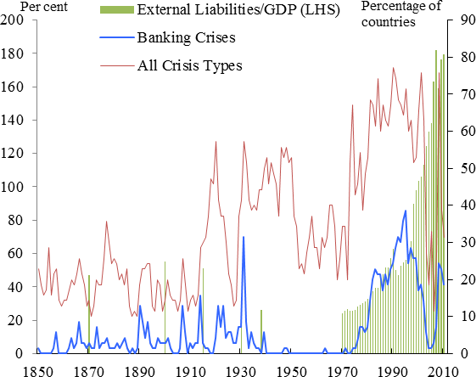**Chart 6: Size of IMF programmes as share of borrower’s IMF quota**

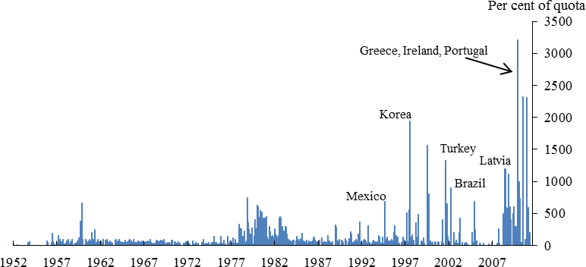

Sources: IMF

|  |  |
| --- | --- |
| **Chart 7: Correlation 10-year spot yields(a)**    Source: Global Financial Database and Bank calculations.  (a) Overlapping 3 year rolling correlation of monthly changes in spot yields. | **Chart 8: Correlation of equity prices(a)**    Source: Bloomberg and Bank calculations.  (a) Overlapping 26 week rolling correlation of weekly changes in log equity prices. FTSE All Share, S&P500 and EuroStoxx 50. |

# Chart 9: Correlation of investment grade corporate bond spreads(a)

Source: BofA Merrill Lynch Global Research, Datastream and Bank calculations.

(a) Overlapping 26 week rolling correlation of weekly changes in investment corporate grade corporate bond spreads.

# Chart 10: Strength of common factor in UK, US and German spot yields at different maturities(a)

15 90

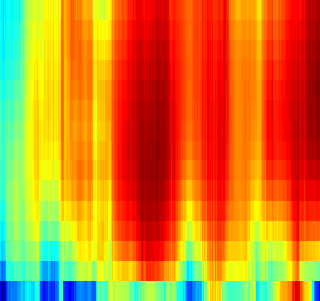

14

13 85

12

80

11

10 75

Maturity, years

9

8 70

7

6 65

5 60

4

3 55

2

1 50

1995 1997 1999 2001 2003 2005 2007 2009 2011 2013

# Chart 11: Strength of common factor in UK, US and German forward rates at different maturities(a)

15 90

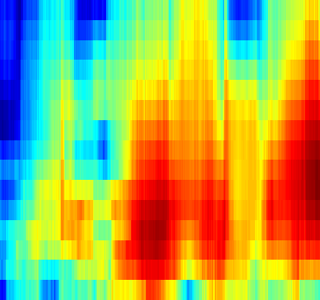

14

13 85

12 80

11

10 75

Maturity, years

9

70

8

7 65

6

5 60

4 55

3

2 50

1

45

1995 1997 1999 2001 2003 2005 2007 2009 2011 2013

Source: Bloomberg and Bank calculations.

(a) Each cell shows the percentage of the variation of weekly changes in UK, US and German interest rates over the past two years explained by the first principal component over those two years. Redder cells indicate a higher percentage, indicating more of a common factor, and bluer cells indicate a lower percentage, indicating less of a common factor.

A previous version of this document had a key going from 0-100%. The current keys are correct.

|  |  |
| --- | --- |
| **Chart 12: International reserves (USD) and as a share of global GDP, 1980-2012** | **Chart 13: IMF resources as a share of global GDP(a)** |
| Sources: IMF IFS, IMF WEO and Bank calculations | Sources: IMF International Financial Statistics, IMF WEO and Bank calculations.  (a) IMF resources include quota, NAB, GAB and bilateral borrowing. |

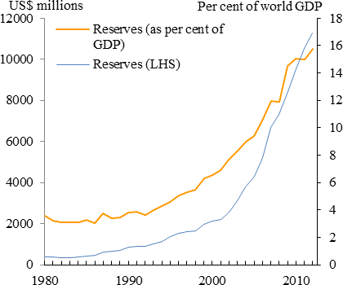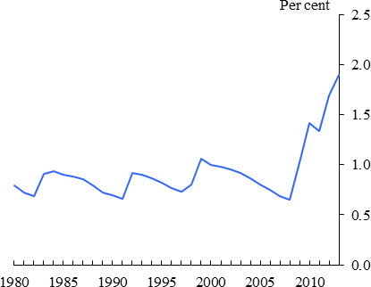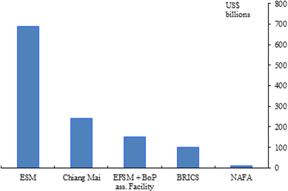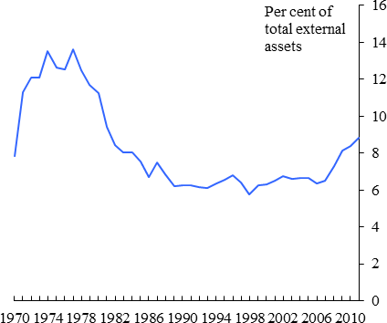

|  |  |
| --- | --- |
| **Chart 14: The 5 largest regional financial arrangements(a)** | **Chart 15: International reserves as a share of global external assets, 1970-2012** |
| Sources: ESM, ABD, FLAR, AMF, BRICS Fortelleza declaration, NAFA, EFSM, EurAsEC ACF.  (a) There many other RFAs including FLAR, AMF EurAsEC ACF. | Sources: IMF IFS and updated and extended version of dataset constructed by Lane and Milesi-Ferretti (2007) |

|  |  |
| --- | --- |
| **Chart 16: International reserves as a share of short term external debt, end-2012** | **Chart 17: Official resources as a share of global external assets** |
| Sources: IMF IFS, World Bank QEDS and Bank calculations | Sources: Sources: IMF International Financial Statistics, IMF WEO, updated and extended version of dataset constructed by Lane and Milesi-Ferretti (2007) and Bank calculations.   1. IMF resources include quota, NAB, GAB and bilateral borrowing. 2. Includes EFSF from 2010 until 2013,; ESM from 2012; CMIM and EFSM from 2010, FLAR, AMF from 2011; BoP Assistance Facility from 2002; Nafa from 1994; EurAsEC ACF from 2009. 3. For swap lines that are formally unlimited, the value of their past maximal drawing was used (where drawn upon). |

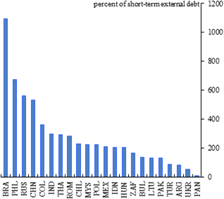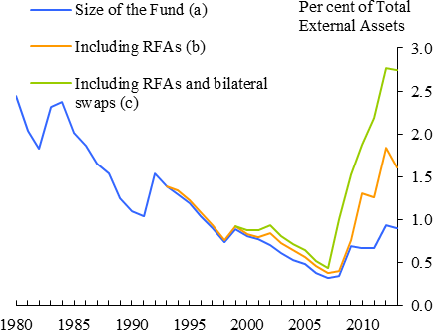

# Chart 18: Cross country asset class correlations

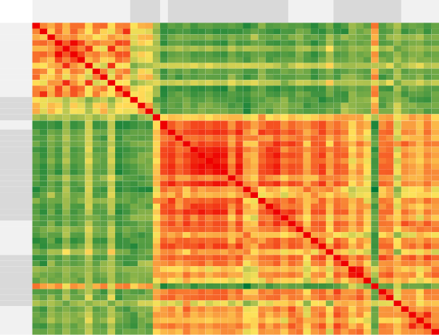

**Bonds**

**EM**

**Bonds**

**Equity**

**EM Equity**

**FX**

**EM FX**

**Credit**

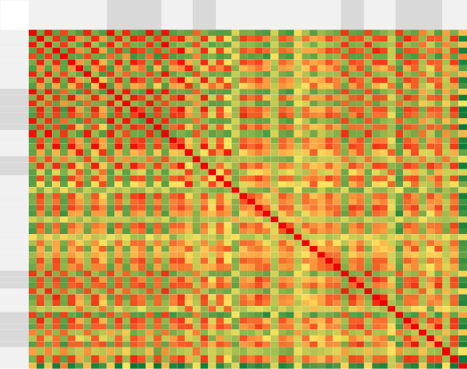

**Europe core**

**periphery Instr.**

**Europe Euro CH**

**Emerging Market**

**CA USA AU & NZ JP**

1 0 1 0 1 0 0 1 0 0 1 0 1 0 0 1 0 1 0 0 0 1 0 0 0 0 0 0 0 0 0 0 0 0 0 0 0 0 0 0 1 0 0 1 0 0 0 1 0 0 1 0 0 0 0 0

0 1 0 1 0 1 1 0 1 0 0 1 0 1 1 0 1 0 1 1 0 0 1 0 1 0 0 1 1 1 1 0 1 1 0 1 0 0 1 1 0 1 1 0 1 1 0 0 1 1 0 1 1 0 1 -1

1 0 1 0 1 0 0 1 0 0 1 0 1 0 0 1 0 1 0 0 0 1 0 0 0 0 0 0 0 0 0 0 0 0 0 0 0 0 0 0 1 0 0 1 0 0 0 1 0 0 1 0 0 1 0 0

0 1 0 1 0 1 1 0 1 0 0 1 0 1 1 0 1 0 1 1 0 0 1 0 1 0 0 1 1 1 1 0 1 1 0 0 0 1 1 1 0 1 1 0 1 1 0 0 1 1 0 1 1 0 1 -1

1 0 1 0 1 0 0 1 0 0 1 0 1 -1 0 1 -1 1 0 0 0 1 0 0 0 0 0 0 0 0 -1 0 0 0 0 0 0 0 0 0 1 0 0 1 0 0 0 1 0 0 1 0 -1 1 0 1

0 1 0 1 0 1 1 0 1 0 0 1 0 1 1 0 1 0 1 1 0 0 1 0 1 0 0 1 1 1 0 0 1 1 0 1 0 0 1 1 0 1 1 0 1 1 0 0 1 1 0 1 1 0 1 -1

0 1 0 1 0 1 1 0 0 1 0 1 0 0 1 0 0 0 0 1 1 0 0 1 1 1 0 0 0 1 0 0 0 0 0 0 1 0 0 1 0 1 1 0 0 0 1 0 0 1 0 0 1 0 0 0

1 0 1 0 1 0 0 1 0 0 1 0 1 0 0 1 0 1 0 0 0 1 0 0 0 0 0 0 0 0 0 0 0 0 0 0 0 0 0 0 1 0 0 1 0 0 0 1 0 0 1 0 0 1 0 0

0 1 0 1 0 1 0 0 1 0 0 1 0 1 1 0 1 0 1 1 0 0 1 0 1 0 0 1 1 1 0 0 1 0 0 1 0 0 1 1 0 1 1 0 1 1 0 0 1 1 0 1 1 0 1 -1

0 0 0 0 0 0 1 0 0 1 0 0 0 0 1 0 0 0 0 0 1 0 0 1 0 1 0 0 0 1 0 0 1 0 0 0 1 0 0 1 0 0 1 0 0 0 1 0 0 1 0 0 1 0 0 -1

1 0 1 0 1 0 0 1 0 0 1 0 1 0 0 1 0 1 0 0 0 1 0 0 0 0 0 0 0 0 0 0 0 -1 0 0 0 0 0 0 1 0 0 1 0 0 0 1 0 0 0 0 0 0 0 0

0 1 0 1 0 1 1 0 1 0 0 1 0 1 1 0 1 0 1 1 0 0 1 0 1 0 0 1 1 1 0 0 1 0 0 1 0 0 1 1 0 1 1 0 1 1 0 0 1 1 0 1 1 0 1 -1

1 0 1 0 1 0 0 1 0 0 1 0 1 0 0 1 0 1 0 0 0 1 0 0 0 0 0 0 0 0 0 0 0 0 0 0 0 0 0 0 1 0 0 1 0 0 0 1 0 0 0 0 0 0 0 0

0 1 0 1 -1 1 0 0 1 0 0 1 0 1 1 0 1 0 1 1 0 0 1 0 1 0 0 1 1 1 1 0 1 1 0 1 0 0 1 0 0 1 1 0 1 1 0 0 1 1 0 1 1 0 1 -1

0 1 0 1 0 1 1 0 1 1 0 1 0 1 1 0 1 0 1 1 0 0 1 0 1 0 0 1 1 1 0 0 1 1 0 1 1 1 1 1 0 1 1 0 1 1 0 0 1 1 0 1 1 0 1 -1

1 0 1 0 1 0 0 1 0 0 1 0 1 0 0 1 0 1 0 0 0 1 0 0 0 0 0 0 0 0 0 0 0 0 0 0 0 0 0 0 1 0 0 1 0 0 0 1 0 0 0 0 0 0 0 0

0 1 0 1 -1 1 0 0 1 0 0 1 0 1 1 0 1 0 1 1 0 0 1 0 1 0 0 1 1 1 1 0 1 1 0 1 0 0 1 0 0 1 1 0 1 1 0 0 1 1 0 1 1 0 1 -1

1 0 1 0 1 0 0 1 0 0 1 0 1 0 0 1 0 1 0 0 0 1 0 0 0 0 0 0 0 0 0 0 0 0 0 0 0 0 0 0 1 0 0 1 0 0 0 1 0 0 1 0 0 1 0 0

0 1 0 1 0 1 0 0 1 0 0 1 0 1 1 0 1 0 1 1 0 0 1 0 1 0 0 1 1 1 0 0 1 1 0 1 0 0 1 1 0 1 1 0 1 1 0 0 1 1 0 0 1 0 1 -1

0 1 0 1 0 1 1 0 1 0 0 1 0 1 1 0 1 0 1 1 0 0 1 0 1 0 0 1 1 1 1 0 1 1 0 1 0 0 1 1 0 1 1 0 1 1 0 0 1 1 0 1 1 0 1 -1

0 0 0 0 0 0 1 0 0 1 0 0 0 0 0 0 0 0 0 0 1 0 0 1 0 1 0 0 0 1 0 0 0 0 0 0 1 0 0 1 0 0 1 0 0 0 1 0 0 1 0 0 1 0 0 0

1 0 1 0 1 0 0 1 0 0 1 0 1 0 0 1 0 1 0 0 0 1 0 0 0 0 0 0 0 0 0 0 0 0 0 0 0 0 0 0 1 0 0 1 0 0 0 1 0 0 1 0 0 1 0 0

0 1 0 1 0 1 0 0 1 0 0 1 0 1 1 0 1 0 1 1 0 0 1 0 1 0 0 1 1 1 0 0 1 1 0 1 0 0 1 0 0 1 1 0 1 1 0 0 1 1 0 1 1 0 1 -1

0 0 0 0 0 0 1 0 0 1 0 0 0 0 0 0 0 0 0 0 1 0 0 1 0 1 0 0 0 0 0 0 0 0 0 0 0 0 0 0 0 0 0 0 0 0 1 0 0 0 0 0 0 0 0 0

0 1 0 1 0 1 1 0 1 0 0 1 0 1 1 0 1 0 1 1 0 0 1 0 1 0 0 1 1 1 1 0 1 1 0 1 1 1 1 1 0 1 1 0 1 1 0 0 1 1 0 0 1 0 1 -1

0 0 0 0 0 0 1 0 0 1 0 0 0 0 0 0 0 0 0 0 1 0 0 1 0 1 0 0 0 0 0 0 0 0 0 0 1 0 0 1 0 0 1 0 0 0 1 0 0 1 0 0 1 0 0 0

0 0 0 0 0 0 0 0 0 0 0 0 0 0 0 0 0 0 0 0 0 0 0 0 0 0 1 0 0 0 0 0 0 0 0 0 0 0 0 0 0 0 0 0 0 0 0 0 0 0 0 0 0 0 0 0

0 1 0 1 0 1 0 0 1 0 0 1 0 1 1 0 1 0 1 1 0 0 1 0 1 0 0 1 1 1 0 0 1 1 0 1 0 0 1 0 0 1 1 0 1 1 0 0 1 1 0 1 0 0 1 -1

0 1 0 1 0 1 0 0 1 0 0 1 0 1 1 0 1 0 1 1 0 0 1 0 1 0 0 1 1 0 0 0 1 0 0 1 1 0 1 0 0 0 1 0 0 1 0 0 1 1 0 1 1 0 1 -1

0 1 0 1 0 1 1 0 1 1 0 1 0 1 1 0 1 0 1 1 1 0 1 0 1 0 0 1 0 1 1 0 1 1 0 0 1 0 1 1 0 1 1 0 1 1 0 0 1 1 0 0 1 0 1 -1

0 1 0 1 -1 0 0 0 0 0 0 0 0 1 0 0 1 0 0 1 0 0 0 0 1 0 0 0 0 1 1 0 0 1 0 0 0 0 1 1 0 1 1 0 1 1 0 -1 0 1 0 0 1 0 1 -1

0 0 0 0 0 0 0 0 0 0 0 0 0 0 0 0 0 0 0 0 0 0 0 0 0 0 0 0 0 0 0 1 0 0 0 0 0 0 0 0 0 0 0 0 0 0 0 0 0 0 0 0 0 0 0 0

0 1 0 1 0 1 0 0 1 1 0 1 0 1 1 0 1 0 1 1 0 0 1 0 1 0 0 1 1 1 0 0 1 1 0 1 1 0 1 0 0 1 1 0 1 1 0 0 1 1 0 1 1 0 1 -1

0 1 0 1 0 1 0 0 0 0 -1 0 0 1 1 0 1 0 1 1 0 0 1 0 1 0 0 1 0 1 1 0 1 1 0 0 1 0 1 1 0 0 1 0 1 0 0 -1 1 1 0 0 1 0 1 -1

0 0 0 0 0 0 0 0 0 0 0 0 0 0 0 0 0 0 0 0 0 0 0 0 0 0 0 0 0 0 0 0 0 0 1 0 0 0 0 0 0 0 0 0 0 0 0 0 0 0 0 0 0 0 0 0

0 1 0 0 0 1 0 0 1 0 0 1 0 1 1 0 1 0 1 1 0 0 1 0 1 0 0 1 1 0 0 0 1 0 0 1 0 0 1 0 0 0 1 0 0 0 0 0 1 0 0 1 0 0 1 -1

0 0 0 0 0 0 1 0 0 1 0 0 0 0 1 0 0 0 0 0 1 0 0 0 1 1 0 0 1 1 0 0 1 1 0 0 1 0 0 1 0 0 1 0 0 0 0 0 0 1 0 0 1 0 0 0

0 0 0 1 0 0 0 0 0 0 0 0 0 0 1 0 0 0 0 0 0 0 0 0 1 0 0 0 0 0 0 0 0 0 0 0 0 1 1 1 0 0 0 0 0 0 0 0 0 0 0 0 0 0 0 0

0 1 0 1 0 1 0 0 1 0 0 1 0 1 1 0 1 0 1 1 0 0 1 0 1 0 0 1 1 1 1 0 1 1 0 1 0 1 1 1 0 1 1 0 1 1 0 0 1 1 0 1 1 0 1 -1

0 1 0 1 0 1 1 0 1 1 0 1 0 0 1 0 0 0 1 1 1 0 0 0 1 1 0 0 0 1 1 0 0 1 0 0 1 1 1 1 0 1 1 0 1 1 0 0 0 1 0 0 1 0 0 0

1 0 1 0 1 0 0 1 0 0 1 0 1 0 0 1 0 1 0 0 0 1 0 0 0 0 0 0 0 0 0 0 0 0 0 0 0 0 0 0 1 0 0 1 0 0 0 1 0 0 1 0 0 0 0 0

0 1 0 1 0 1 1 0 1 0 0 1 0 1 1 0 1 0 1 1 0 0 1 0 1 0 0 1 0 1 1 0 1 0 0 0 0 0 1 1 0 1 1 0 1 1 0 0 1 1 0 1 1 0 1 -1

0 1 0 1 0 1 1 0 1 1 0 1 0 1 1 0 1 0 1 1 1 0 1 0 1 1 0 1 1 1 1 0 1 1 0 1 1 0 1 1 0 1 1 0 1 1 0 0 1 1 0 0 1 0 1 -1

1 0 1 0 1 0 0 1 0 0 1 0 1 0 0 1 0 1 0 0 0 1 0 0 0 0 0 0 0 0 0 0 0 0 0 0 0 0 0 0 1 0 0 1 0 0 0 1 0 0 1 0 0 0 0 0

0 1 0 1 0 1 0 0 1 0 0 1 0 1 1 0 1 0 1 1 0 0 1 0 1 0 0 1 0 1 1 0 1 1 0 0 0 0 1 1 0 1 1 0 1 1 0 0 1 1 0 0 1 0 1 -1

0 1 0 1 0 1 0 0 1 0 0 1 0 1 1 0 1 0 1 1 0 0 1 0 1 0 0 1 1 1 1 0 1 0 0 0 0 0 1 1 0 1 1 0 1 1 0 0 1 1 0 1 1 0 1 -1

0 0 0 0 0 0 1 0 0 1 0 0 0 0 0 0 0 0 0 0 1 0 0 1 0 1 0 0 0 0 0 0 0 0 0 0 0 0 0 0 0 0 0 0 0 0 1 0 0 0 0 0 0 0 0 0

1 0 1 0 1 0 0 1 0 0 1 0 1 0 0 1 0 1 0 0 0 1 0 0 0 0 0 0 0 0 -1 0 0 -1 0 0 0 0 0 0 1 0 0 1 0 0 0 1 0 0 1 0 0 1 0 0

0 1 0 1 0 1 0 0 1 0 0 1 0 1 1 0 1 0 1 1 0 0 1 0 1 0 0 1 1 1 0 0 1 1 0 1 0 0 1 0 0 1 1 0 1 1 0 0 1 1 0 1 1 0 1 -1

0 1 0 1 0 1 1 0 1 1 0 1 0 1 1 0 1 0 1 1 1 0 1 0 1 1 0 1 1 1 1 0 1 1 0 0 1 0 1 1 0 1 1 0 1 1 0 0 1 1 0 0 1 0 1 -1

1 0 1 0 1 0 0 1 0 0 0 0 0 0 0 0 0 1 0 0 0 1 0 0 0 0 0 0 0 0 0 0 0 0 0 0 0 0 0 0 1 0 0 1 0 0 0 1 0 0 1 0 0 0 0 0

0 1 0 1 0 1 0 0 1 0 0 1 0 1 1 0 1 0 0 1 0 0 1 0 0 0 0 1 1 0 0 0 1 0 0 1 0 0 1 0 0 1 0 0 0 1 0 0 1 0 0 1 0 0 1 -1

0 1 0 1 -1 1 1 0 1 1 0 1 0 1 1 0 1 0 1 1 1 0 1 0 1 1 0 0 1 1 1 0 1 1 0 0 1 0 1 1 0 1 1 0 1 1 0 0 1 1 0 0 1 0 1 -1

0 0 1 0 1 0 0 1 0 0 0 0 0 0 0 0 0 1 0 0 0 1 0 0 0 0 0 0 0 0 0 0 0 0 0 0 0 0 0 0 0 0 0 0 0 0 0 1 0 0 0 0 0 1 0 0

0 1 0 1 0 1 0 0 1 0 0 1 0 1 1 0 1 0 1 1 0 0 1 0 1 0 0 1 1 1 1 0 1 1 0 1 0 0 1 0 0 1 1 0 1 1 0 0 1 1 0 1 1 0 1 -1

0 -1 0 -1 1 -1 0 0 -1 -1 0 -1 0 -1 -1 0 -1 0 -1 -1 0 0 -1 0 -1 0 0 -1 -1 -1 -1 0 -1 -1 0 -1 0 0 -1 0 0 -1 -1 0 -1 -1 0 0 -1 -1 0 -1 -1 0 -1 1

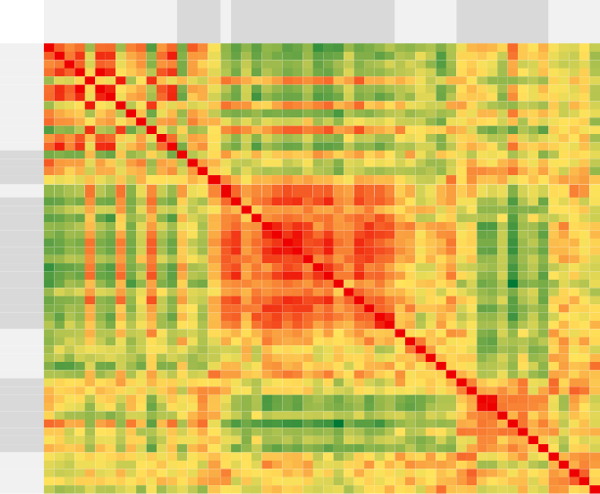

**Bonds**

**EM**

**Bonds**

**Equity**

**EM**

**Equity**

**FX**

**EM FX**

**Credit**

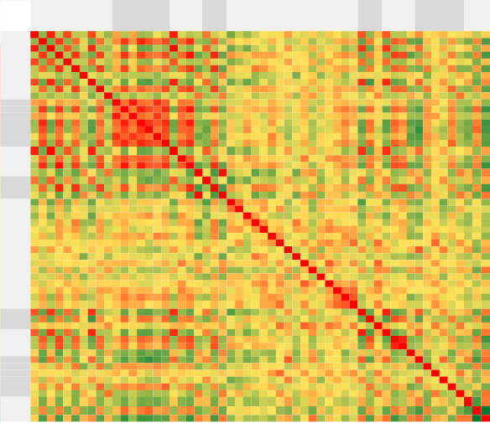

**Europe core**

**periphery Instr.**

**Europe Euro CH**

**Emerging Market**

**CA USA AU & NZ JP**

1 0 1 0 1 0 0 1 0 0 0 0 0 0 0 0 0 1 0 0 0 1 0 0 0 0 0 0 0 0 0 0 0 0 0 0 0 0 0 0 1 0 0 1 0 0 0 0 0 0 0 0 0 0 0 0

0 1 0 1 0 1 0 0 1 0 0 1 0 1 1 1 1 0 1 1 0 0 1 0 0 0 0 0 0 0 0 0 0 0 0 0 0 0 0 0 0 1 0 0 1 1 0 0 0 0 0 0 0 0 0 0

1 0 1 0 1 0 0 1 0 0 0 0 0 0 0 0 0 1 0 0 0 1 0 0 0 0 0 0 0 0 0 0 0 0 0 0 0 0 0 0 1 0 0 1 0 0 0 1 0 0 0 0 0 0 0 0

0 1 0 1 0 1 0 0 1 0 0 1 0 1 1 1 1 0 1 1 0 0 1 0 0 0 0 0 0 0 0 0 0 0 0 0 0 0 0 0 0 1 0 0 1 1 0 0 0 0 0 1 0 0 1 0

1 0 1 0 1 0 0 1 0 0 0 0 0 0 0 0 0 1 0 0 0 0 0 0 0 0 0 0 0 0 0 0 0 0 0 0 0 0 0 0 1 0 0 1 0 0 0 0 0 0 0 0 0 0 0 0

0 1 0 1 0 1 0 0 1 0 0 1 0 1 0 0 1 0 1 1 0 0 1 0 0 0 0 1 0 0 0 0 0 0 0 0 0 0 0 0 0 1 0 0 1 1 0 0 1 0 0 1 0 0 0 0

0 0 0 0 0 0 1 0 0 0 0 0 0 0 0 0 0 0 0 0 0 0 0 0 0 0 0 0 0 0 0 0 0 0 0 0 0 0 0 0 0 0 0 0 0 0 0 0 0 0 0 0 0 0 0 0

1 0 1 0 1 0 0 1 0 0 0 0 0 0 0 0 0 1 0 0 0 1 0 0 0 0 0 0 0 0 0 0 0 0 0 0 0 0 0 0 1 0 0 1 0 0 0 1 0 0 0 0 0 0 0 0

0 1 0 1 0 1 0 0 1 0 0 1 0 1 0 1 1 0 1 1 0 0 1 0 0 0 0 0 0 0 0 0 0 0 0 0 0 0 0 0 0 0 0 0 1 1 0 0 1 0 0 1 0 0 0 0

0 0 0 0 0 0 0 0 0 1 0 0 0 0 0 0 0 0 0 0 1 0 0 1 0 0 0 0 0 0 0 0 0 0 0 0 0 0 0 0 0 0 0 0 0 0 0 0 0 0 0 0 1 0 0 0

0 0 0 0 0 0 0 0 0 0 1 1 1 1 1 1 1 0 1 1 0 0 0 0 0 0 0 0 0 0 0 0 0 0 0 0 0 0 0 0 0 0 0 0 0 0 0 0 0 0 0 0 0 0 0 0

0 1 0 1 0 1 0 0 1 0 1 1 1 1 1 1 1 0 1 1 0 0 1 0 0 0 0 0 0 0 0 0 0 0 0 0 0 0 1 0 0 1 0 0 1 1 0 0 0 0 0 1 0 0 1 -1

0 0 0 0 0 0 0 0 0 0 1 1 1 1 1 1 1 0 1 0 0 0 0 0 0 0 0 0 0 0 0 0 0 0 0 0 0 0 0 0 0 0 0 0 0 0 0 0 0 0 0 0 0 0 0 0

0 1 0 1 0 1 0 0 1 0 1 1 1 1 1 1 1 0 1 1 0 0 1 0 0 0 0 0 0 0 0 0 0 0 0 0 0 0 1 0 0 1 0 0 1 0 0 0 0 0 0 1 0 0 1 -1

0 1 0 1 0 0 0 0 0 0 1 1 1 1 1 1 1 0 1 1 0 0 0 0 0 0 0 0 0 0 0 0 0 0 0 0 0 0 0 0 0 1 0 0 1 0 0 -1 0 0 0 0 0 0 1 0

0 1 0 1 0 0 0 0 1 0 1 1 1 1 1 1 1 0 0 1 0 0 0 0 0 0 0 0 0 1 0 0 0 0 0 0 0 0 0 0 0 0 0 0 0 0 0 0 0 0 0 0 0 0 0 0

0 1 0 1 0 1 0 0 1 0 1 1 1 1 1 1 1 0 1 1 0 0 1 0 0 0 0 0 0 0 0 0 0 0 0 0 0 0 0 0 0 1 0 0 1 1 0 0 0 0 0 1 0 0 0 0

1 0 1 0 1 0 0 1 0 0 0 0 0 0 0 0 0 1 0 0 0 1 0 0 0 0 0 0 0 0 0 0 0 0 0 0 0 0 0 0 1 0 0 1 0 0 0 1 0 0 0 0 0 0 0 0

0 1 0 1 0 1 0 0 1 0 1 1 1 1 1 0 1 0 1 1 0 0 0 0 0 0 0 0 0 0 0 0 0 1 0 0 0 0 0 0 0 0 0 0 1 0 0 0 0 0 0 0 0 0 0 0

0 1 0 1 0 1 0 0 1 0 1 1 0 1 1 1 1 0 1 1 0 0 1 0 0 0 0 0 0 0 0 0 0 0 0 0 0 0 1 0 0 1 0 0 1 1 0 0 0 0 0 1 0 0 1 -1

0 0 0 0 0 0 0 0 0 1 0 0 0 0 0 0 0 0 0 0 1 0 0 1 0 0 0 0 0 0 0 0 0 0 0 0 0 0 0 0 0 0 0 0 0 0 0 0 0 0 0 0 1 0 0 1

1 0 1 0 0 0 0 1 0 0 0 0 0 0 0 0 0 1 0 0 0 1 0 0 0 0 0 0 0 0 0 0 0 0 0 0 0 0 0 0 1 0 0 0 0 0 0 0 0 0 0 0 0 0 0 0

0 1 0 1 0 1 0 0 1 0 0 1 0 1 0 0 1 0 0 1 0 0 1 0 0 0 0 1 1 0 0 0 0 0 0 0 0 0 0 0 0 0 0 0 1 1 0 0 0 0 0 0 0 0 0 0

0 0 0 0 0 0 0 0 0 1 0 0 0 0 0 0 0 0 0 0 1 0 0 1 0 0 0 0 0 0 0 0 0 0 0 0 0 0 0 0 0 0 0 0 0 0 0 0 0 0 0 0 1 0 0 1

0 0 0 0 0 0 0 0 0 0 0 0 0 0 0 0 0 0 0 0 0 0 0 0 1 1 0 0 0 0 0 0 0 0 0 0 0 0 0 0 0 0 0 0 0 0 0 0 0 0 0 0 0 0 0 0

0 0 0 0 0 0 0 0 0 0 0 0 0 0 0 0 0 0 0 0 0 0 0 0 1 1 0 0 0 0 0 0 0 0 0 0 0 0 0 0 0 0 0 0 0 0 0 0 0 0 0 0 0 0 0 0

0 0 0 0 0 0 0 0 0 0 0 0 0 0 0 0 0 0 0 0 0 0 0 0 0 0 1 0 0 0 0 0 0 0 0 0 0 0 0 0 0 0 0 0 0 0 0 0 0 0 0 0 0 0 0 0

0 0 0 0 0 1 0 0 0 0 0 0 0 0 0 0 0 0 0 0 0 0 1 0 0 0 0 1 0 0 0 0 1 0 0 0 0 0 0 0 0 0 0 0 0 0 0 0 0 0 0 0 0 0 0 0

0 0 0 0 0 0 0 0 0 0 0 0 0 0 0 0 0 0 0 0 0 0 1 0 0 0 0 0 1 0 0 0 0 0 0 0 0 0 0 0 0 0 0 0 0 0 0 0 0 0 0 0 0 0 0 0

0 0 0 0 0 0 0 0 0 0 0 0 0 0 0 1 0 0 0 0 0 0 0 0 0 0 0 0 0 1 0 0 0 0 0 0 0 0 0 0 0 0 0 0 0 0 0 0 0 0 0 0 0 0 0 0

0 0 0 0 0 0 0 0 0 0 0 0 0 0 0 0 0 0 0 0 0 0 0 0 0 0 0 0 0 0 1 0 0 0 0 0 0 0 0 1 0 0 1 0 0 0 0 0 0 1 0 0 0 0 0 0

0 0 0 0 0 0 0 0 0 0 0 0 0 0 0 0 0 0 0 0 0 0 0 0 0 0 0 0 0 0 0 1 0 0 0 0 0 0 0 0 0 0 0 0 0 0 0 1 0 0 1 0 0 0 0 0

0 0 0 0 0 0 0 0 0 0 0 0 0 0 0 0 0 0 0 0 0 0 0 0 0 0 0 1 0 0 0 0 1 0 0 0 0 0 0 0 0 0 0 0 0 0 0 0 0 0 0 0 0 0 0 0

0 0 0 0 0 0 0 0 0 0 0 0 0 0 0 0 0 0 1 0 0 0 0 0 0 0 0 0 0 0 0 0 0 1 0 0 1 0 0 0 0 0 1 0 0 0 0 0 0 0 0 0 0 0 0 0

0 0 0 0 0 0 0 0 0 0 0 0 0 0 0 0 0 0 0 0 0 0 0 0 0 0 0 0 0 0 0 0 0 0 1 0 0 0 0 0 0 0 0 0 0 0 0 0 0 0 0 0 0 0 0 1

0 0 0 0 0 0 0 0 0 0 0 0 0 0 0 0 0 0 0 0 0 0 0 0 0 0 0 0 0 0 0 0 0 0 0 1 0 0 0 0 0 0 0 0 0 0 0 0 0 0 0 0 0 0 0 0

0 0 0 0 0 0 0 0 0 0 0 0 0 0 0 0 0 0 0 0 0 0 0 0 0 0 0 0 0 0 0 0 0 1 0 0 1 0 0 0 0 0 1 0 0 0 0 0 0 0 0 0 0 0 0 0

0 0 0 0 0 0 0 0 0 0 0 0 0 0 0 0 0 0 0 0 0 0 0 0 0 0 0 0 0 0 0 0 0 0 0 0 0 1 1 1 0 0 0 0 0 0 0 0 0 0 0 0 0 0 0 0

0 0 0 0 0 0 0 0 0 0 0 1 0 1 0 0 0 0 0 1 0 0 0 0 0 0 0 0 0 0 0 0 0 0 0 0 0 1 1 1 0 0 0 0 0 0 0 0 0 0 0 0 0 0 0 0

0 0 0 0 0 0 0 0 0 0 0 0 0 0 0 0 0 0 0 0 0 0 0 0 0 0 0 0 0 0 1 0 0 0 0 0 0 1 1 1 0 0 1 0 0 0 0 0 0 0 0 0 0 0 0 0

1 0 1 0 1 0 0 1 0 0 0 0 0 0 0 0 0 1 0 0 0 1 0 0 0 0 0 0 0 0 0 0 0 0 0 0 0 0 0 0 1 0 0 1 0 0 0 1 0 0 0 0 0 0 0 1

0 1 0 1 0 1 0 0 0 0 0 1 0 1 1 0 1 0 0 1 0 0 0 0 0 0 0 0 0 0 0 0 0 0 0 0 0 0 0 0 0 1 0 0 1 1 0 0 0 0 0 1 0 0 0 0

0 0 0 0 0 0 0 0 0 0 0 0 0 0 0 0 0 0 0 0 0 0 0 0 0 0 0 0 0 0 1 0 0 1 0 0 1 0 0 1 0 0 1 0 0 0 0 0 0 1 0 0 1 0 0 0

1 0 1 0 1 0 0 1 0 0 0 0 0 0 0 0 0 1 0 0 0 0 0 0 0 0 0 0 0 0 0 0 0 0 0 0 0 0 0 0 1 0 0 1 0 0 0 1 0 0 0 0 0 0 0 1

0 1 0 1 0 1 0 0 1 0 0 1 0 1 1 0 1 0 1 1 0 0 1 0 0 0 0 0 0 0 0 0 0 0 0 0 0 0 0 0 0 1 0 0 1 1 0 0 0 0 0 0 0 0 1 0

0 1 0 1 0 1 0 0 1 0 0 1 0 0 0 0 1 0 0 1 0 0 1 0 0 0 0 0 0 0 0 0 0 0 0 0 0 0 0 0 0 1 0 0 1 1 0 0 0 0 0 0 0 0 0 0

0 0 0 0 0 0 0 0 0 0 0 0 0 0 0 0 0 0 0 0 0 0 0 0 0 0 0 0 0 0 0 0 0 0 0 0 0 0 0 0 0 0 0 0 0 0 1 0 0 0 0 0 0 0 0 1

0 0 1 0 0 0 0 1 0 0 0 0 0 0 -1 0 0 1 0 0 0 0 0 0 0 0 0 0 0 0 0 1 0 0 0 0 0 0 0 0 1 0 0 1 0 0 0 1 0 0 1 0 0 1 0 1

0 0 0 0 0 1 0 0 1 0 0 0 0 0 0 0 0 0 0 0 0 0 0 0 0 0 0 0 0 0 0 0 0 0 0 0 0 0 0 0 0 0 0 0 0 0 0 0 1 0 0 0 0 0 0 0

0 0 0 0 0 0 0 0 0 0 0 0 0 0 0 0 0 0 0 0 0 0 0 0 0 0 0 0 0 0 1 0 0 0 0 0 0 0 0 0 0 0 1 0 0 0 0 0 0 1 0 0 1 0 0 0

0 0 0 0 0 0 0 0 0 0 0 0 0 0 0 0 0 0 0 0 0 0 0 0 0 0 0 0 0 0 0 1 0 0 0 0 0 0 0 0 0 0 0 0 0 0 0 1 0 0 1 0 0 0 0 0

0 0 0 1 0 1 0 0 1 0 0 1 0 1 0 0 1 0 0 1 0 0 0 0 0 0 0 0 0 0 0 0 0 0 0 0 0 0 0 0 0 1 0 0 0 0 0 0 0 0 0 1 0 0 0 0

0 0 0 0 0 0 0 0 0 1 0 0 0 0 0 0 0 0 0 0 1 0 0 1 0 0 0 0 0 0 0 0 0 0 0 0 0 0 0 0 0 0 1 0 0 0 0 0 0 1 0 0 1 0 0 1

0 0 0 0 0 0 0 0 0 0 0 0 0 0 0 0 0 0 0 0 0 0 0 0 0 0 0 0 0 0 0 0 0 0 0 0 0 0 0 0 0 0 0 0 0 0 0 1 0 0 0 0 0 1 0 1

0 0 0 1 0 0 0 0 0 0 0 1 0 1 1 0 0 0 0 1 0 0 0 0 0 0 0 0 0 0 0 0 0 0 0 0 0 0 0 0 0 0 0 0 1 0 0 0 0 0 0 0 0 0 1 -1

0 0 0 0 0 0 0 0 0 0 0 -1 0 -1 0 0 0 0 0 -1 1 0 0 1 0 0 0 0 0 0 0 0 0 0 1 0 0 0 0 0 1 0 0 1 0 0 1 1 0 0 0 0 1 1 -1 1

**May to August 2014**

**September to December 2008**

**March to June 2005**

**EM**

**Bond s**

**EM**

**Curren**

**EM**

**Equity**

**EM FX**

**EM**

**Equity**

**EM**

**Bonds**

**Currencies**

**FX**

**Equity**

**Bonds**

**EM FX**

**FX**

**EM Equity**

**Equity**

**Bonds**

**Credit**

**Credit**

**AU &**

**AU &**

**Euro Europe**

**AU &**

**Euro Europe**

**JP USA CA Emerging Market**

**CH Instr. periphery Europe core**

**JP USA CA Emerging Market**

**CH Instr. periphery Europe core**

**ore**

**NZ**

**NZ**

**NZ**

**Ordered by asset Ordered by country**

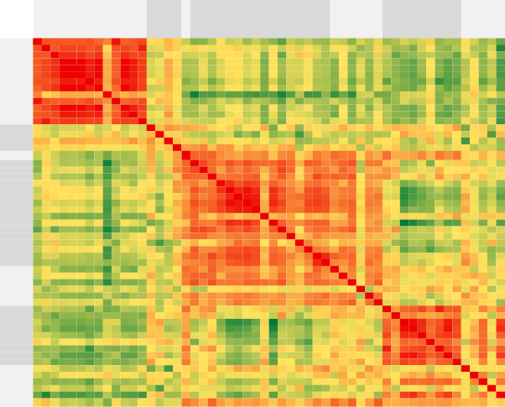

**Bonds**

**EM**

**Bonds**

**Equity**

**EM**

**Equity**

**FX**

**EM FX**

1 1 1 1 1 1 1 1 0 1 1 1 1 0 0 0 0 0 0 0 0 0 0 0 0 0 0 0 0 0 0 0 0 0 0 0 0 0 0 0 0 0 0 0 0 0 0 0 0 0 0 0 0 0

1 1 1 1 1 1 1 1 0 1 1 1 1 0 0 0 0 0 0 0 0 0 0 0 0 0 0 0 0 0 0 0 0 0 0 0 0 0 0 0 0 0 0 0 0 0 0 0 0 0 0 0 0 0

1 1 1 1 1 1 1 1 0 1 1 1 1 0 0 0 0 0 0 0 0 0 0 0 0 0 0 0 0 0 0 0 0 0 0 0 0 0 0 0 0 0 0 0 0 0 0 0 0 0 0 0 0 0

1 1 1 1 1 1 1 1 0 1 1 1 1 0 0 0 0 0 0 0 0 0 0 0 0 0 0 0 0 0 0 0 0 0 0 0 0 0 0 0 0 0 0 0 0 0 0 0 0 0 0 0 0 0

1 1 1 1 1 1 1 1 0 1 1 1 1 0 0 0 0 0 0 0 0 0 0 0 0 0 0 0 0 0 0 0 0 0 0 0 0 0 0 0 0 0 0 0 0 0 0 0 0 0 0 0 0 0

1 1 1 1 1 1 1 1 0 1 1 1 1 0 0 0 0 0 0 0 0 0 0 0 0 0 0 0 0 0 0 0 0 0 0 0 0 0 0 0 0 0 0 0 0 0 0 0 0 0 0 0 0 0

1 1 1 1 1 1 1 1 0 1 1 1 1 0 0 0 0 0 0 0 0 0 0 0 0 0 0 0 0 0 0 0 0 0 0 0 0 0 0 0 0 0 0 0 0 0 0 0 0 0 0 0 0 0

1 1 1 1 1 1 1 1 0 1 1 1 1 0 0 0 0 0 0 0 0 0 0 0 0 0 0 0 0 0 0 0 0 0 0 0 0 0 0 0 0 0 0 0 0 0 0 0 0 0 0 0 0 0

0 0 0 0 0 0 0 0 1 0 0 0 0 0 0 0 0 0 -1 0 0 0 0 0 0 0 0 0 -1 0 0 0 0 0 0 0 0 0 0 0 0 0 0 0 0 0 0 0 0 0 0 0 0 0

1 1 1 1 1 1 1 1 0 1 1 1 1 0 0 0 0 0 0 0 0 0 0 0 0 0 0 0 0 0 0 0 0 0 0 0 0 0 0 0 0 0 0 0 0 0 0 0 0 0 0 0 0 0

1 1 1 1 1 1 1 1 0 1 1 1 1 0 0 0 0 0 0 0 0 0 0 0 0 0 0 0 0 0 0 0 0 0 0 0 0 0 0 0 0 0 0 0 0 0 0 0 0 0 0 0 0 0

1 1 1 1 1 1 1 1 0 1 1 1 1 0 0 0 0 0 0 0 0 0 0 0 0 0 0 0 0 0 0 0 0 0 0 0 0 0 0 0 0 0 0 0 0 0 0 0 0 0 0 0 0 0

1 1 1 1 1 1 1 1 0 1 1 1 1 0 0 0 0 0 0 0 0 0 0 0 0 0 0 0 0 0 0 0 0 0 0 0 0 0 0 0 0 0 0 0 0 0 0 0 0 0 0 0 0 0

0 0 0 0 0 0 0 0 0 0 0 0 0 1 0 0 0 0 0 0 0 0 0 0 0 0 0 0 0 0 0 0 0 0 0 0 0 0 0 0 0 0 0 0 0 0 0 0 0 0 0 0 0 0

0 0 0 0 0 0 0 0 0 0 0 0 0 0 1 0 0 0 0 0 0 0 0 0 0 0 0 0 0 0 0 0 0 0 0 0 0 0 0 0 0 0 0 0 0 0 0 0 0 0 0 0 0 0

0 0 0 0 0 0 0 0 0 0 0 0 0 0 0 1 0 0 0 0 0 0 0 0 0 0 0 0 0 0 0 0 0 0 0 0 0 0 0 0 0 0 0 0 0 0 0 0 0 0 0 0 0 0

0 0 0 0 0 0 0 0 0 0 0 0 0 0 0 0 1 0 0 0 0 0 0 0 0 0 0 0 0 0 0 0 0 0 0 0 0 0 0 0 0 0 0 0 0 0 0 0 0 0 0 0 0 0

**Credit** 0 0 0 0 0 0 0 0 0 0 0 0 0 0 0 0 0 1 1 1 1 0 0 0 0 0 0 0 0 0 0 0 0 0 1 0 0 0 0 0 1 0 0 0 0 0 0 0 0 0 0 0 0 0

0 0 0 0 0 0 0 0 -1 0 0 0 0 0 0 0 0 1 1 1 1 0 1 1 1 1 1 1 1 1 0 1 1 0 0 1 1 0 0 0 0 0 0 0 0 0 0 0 0 0 0 0 0 0

0 0 0 0 0 0 0 0 0 0 0 0 0 0 0 0 0 1 1 1 1 0 1 0 1 1 0 0 1 1 0 0 1 0 0 1 0 0 0 0 0 0 0 0 0 0 0 0 0 0 0 0 0 0

0 0 0 0 0 0 0 0 0 0 0 0 0 0 0 0 0 1 1 1 1 0 1 1 1 1 0 0 1 0 0 0 1 1 1 1 1 0 0 0 0 0 0 0 0 0 0 0 0 0 0 0 0 0

0 0 0 0 0 0 0 0 0 0 0 0 0 0 0 0 0 0 0 0 0 1 1 1 1 1 0 1 0 0 0 1 1 0 0 0 1 0 0 0 0 0 0 0 0 0 0 0 0 0 0 0 0 0

0 0 0 0 0 0 0 0 0 0 0 0 0 0 0 0 0 0 1 1 1 1 1 1 1 1 0 1 1 0 0 1 1 1 0 0 1 0 0 0 0 0 0 0 0 0 0 0 0 0 0 0 0 0

0 0 0 0 0 0 0 0 0 0 0 0 0 0 0 0 0 0 1 0 1 1 1 1 1 1 0 1 1 0 1 1 1 1 0 0 0 0 0 1 0 0 0 0 0 0 0 0 0 0 0 0 0 0

0 0 0 0 0 0 0 0 0 0 0 0 0 0 0 0 0 0 1 1 1 1 1 1 1 1 0 1 1 0 0 1 1 1 0 1 1 0 0 0 0 0 0 0 0 0 0 0 0 0 0 0 0 0

0 0 0 0 0 0 0 0 0 0 0 0 0 0 0 0 0 0 1 1 1 1 1 1 1 1 0 1 1 0 1 1 1 1 0 0 1 0 0 0 0 0 0 0 0 0 0 0 0 0 0 0 0 0

0 0 0 0 0 0 0 0 0 0 0 0 0 0 0 0 0 0 1 0 0 0 0 0 0 0 1 0 0 0 0 0 0 0 0 0 1 0 0 0 0 0 0 0 0 0 0 0 0 0 0 0 0 0

0 0 0 0 0 0 0 0 0 0 0 0 0 0 0 0 0 0 1 0 0 1 1 1 1 1 0 1 1 0 0 1 1 1 0 0 1 0 0 0 0 0 -1 -1 0 0 0 0 0 0 0 0 0 0

0 0 0 0 0 0 0 0 -1 0 0 0 0 0 0 0 0 0 1 1 1 0 1 1 1 1 0 1 1 0 0 0 1 1 0 1 1 0 0 0 0 0 0 0 0 0 0 0 0 0 0 0 0 0

0 0 0 0 0 0 0 0 0 0 0 0 0 0 0 0 0 0 1 1 0 0 0 0 0 0 0 0 0 1 0 0 0 0 0 0 0 0 0 0 0 0 0 0 0 0 0 0 0 0 0 0 0 0

0 0 0 0 0 0 0 0 0 0 0 0 0 0 0 0 0 0 0 0 0 0 0 1 0 1 0 0 0 0 1 0 0 0 0 0 0 0 0 0 0 0 0 0 0 0 0 0 0 0 0 0 0 0

0 0 0 0 0 0 0 0 0 0 0 0 0 0 0 0 0 0 1 0 0 1 1 1 1 1 0 1 0 0 0 1 1 0 0 1 0 0 0 0 0 0 0 0 0 0 0 0 0 0 0 0 0 0

0 0 0 0 0 0 0 0 0 0 0 0 0 0 0 0 0 0 1 1 1 1 1 1 1 1 0 1 1 0 0 1 1 1 1 1 1 0 0 1 0 0 0 0 0 0 0 0 0 0 0 0 0 0

0 0 0 0 0 0 0 0 0 0 0 0 0 0 0 0 0 0 0 0 1 0 1 1 1 1 0 1 1 0 0 0 1 1 0 0 1 0 1 0 0 0 0 0 0 0 0 0 0 0 0 0 0 0

0 0 0 0 0 0 0 0 0 0 0 0 0 0 0 0 0 1 0 0 1 0 0 0 0 0 0 0 0 0 0 0 1 0 1 0 0 0 0 0 0 0 0 0 0 0 0 0 0 0 0 0 0 0

0 0 0 0 0 0 0 0 0 0 0 0 0 0 0 0 0 0 1 1 1 0 0 0 1 0 0 0 1 0 0 1 1 0 0 1 0 0 0 1 0 0 0 0 0 0 0 0 0 0 0 0 0 0

0 0 0 0 0 0 0 0 0 0 0 0 0 0 0 0 0 0 1 0 1 1 1 0 1 1 1 1 1 0 0 0 1 1 0 0 1 0 0 1 0 0 0 0 0 0 0 0 0 0 0 0 0 0

0 0 0 0 0 0 0 0 0 0 0 0 0 0 0 0 0 0 0 0 0 0 0 0 0 0 0 0 0 0 0 0 0 0 0 0 0 1 0 0 0 0 0 0 0 0 0 0 0 0 0 0 0 0

0 0 0 0 0 0 0 0 0 0 0 0 0 0 0 0 0 0 0 0 0 0 0 0 0 0 0 0 0 0 0 0 0 1 0 0 0 0 1 1 0 0 0 0 0 0 0 0 0 0 0 0 0 0

0 0 0 0 0 0 0 0 0 0 0 0 0 0 0 0 0 0 0 0 0 0 0 1 0 0 0 0 0 0 0 0 1 0 0 1 1 0 1 1 0 0 0 0 0 0 0 0 0 0 0 0 0 0

0 0 0 0 0 0 0 0 0 0 0 0 0 0 0 0 0 1 0 0 0 0 0 0 0 0 0 0 0 0 0 0 0 0 0 0 0 0 0 0 1 0 1 1 1 1 1 1 1 0 0 0 0 0

0 0 0 0 0 0 0 0 0 0 0 0 0 0 0 0 0 0 0 0 0 0 0 0 0 0 0 0 0 0 0 0 0 0 0 0 0 0 0 0 0 1 0 0 0 0 0 0 1 0 0 0 0 0

0 0 0 0 0 0 0 0 0 0 0 0 0 0 0 0 0 0 0 0 0 0 0 0 0 0 0 -1 0 0 0 0 0 0 0 0 0 0 0 0 1 0 1 1 1 1 1 1 1 0 0 1 0 1

0 0 0 0 0 0 0 0 0 0 0 0 0 0 0 0 0 0 0 0 0 0 0 0 0 0 0 -1 0 0 0 0 0 0 0 0 0 0 0 0 1 0 1 1 1 1 1 1 1 0 0 1 0 1

0 0 0 0 0 0 0 0 0 0 0 0 0 0 0 0 0 0 0 0 0 0 0 0 0 0 0 0 0 0 0 0 0 0 0 0 0 0 0 0 1 0 1 1 1 1 1 1 1 0 0 1 0 1

0 0 0 0 0 0 0 0 0 0 0 0 0 0 0 0 0 0 0 0 0 0 0 0 0 0 0 0 0 0 0 0 0 0 0 0 0 0 0 0 1 0 1 1 1 1 1 1 0 0 0 1 0 0

0 0 0 0 0 0 0 0 0 0 0 0 0 0 0 0 0 0 0 0 0 0 0 0 0 0 0 0 0 0 0 0 0 0 0 0 0 0 0 0 1 0 1 1 1 1 1 1 1 0 0 1 0 1

0 0 0 0 0 0 0 0 0 0 0 0 0 0 0 0 0 0 0 0 0 0 0 0 0 0 0 0 0 0 0 0 0 0 0 0 0 0 0 0 1 0 1 1 1 1 1 1 1 0 0 1 0 1

0 0 0 0 0 0 0 0 0 0 0 0 0 0 0 0 0 0 0 0 0 0 0 0 0 0 0 0 0 0 0 0 0 0 0 0 0 0 0 0 1 1 1 1 1 0 1 1 1 0 0 0 0 0

0 0 0 0 0 0 0 0 0 0 0 0 0 0 0 0 0 0 0 0 0 0 0 0 0 0 0 0 0 0 0 0 0 0 0 0 0 0 0 0 0 0 0 0 0 0 0 0 0 1 0 0 0 0

0 0 0 0 0 0 0 0 0 0 0 0 0 0 0 0 0 0 0 0 0 0 0 0 0 0 0 0 0 0 0 0 0 0 0 0 0 0 0 0 0 0 0 0 0 0 0 0 0 0 1 0 0 0

0 0 0 0 0 0 0 0 0 0 0 0 0 0 0 0 0 0 0 0 0 0 0 0 0 0 0 0 0 0 0 0 0 0 0 0 0 0 0 0 0 0 1 1 1 1 1 1 0 0 0 1 0 0

0 0 0 0 0 0 0 0 0 0 0 0 0 0 0 0 0 0 0 0 0 0 0 0 0 0 0 0 0 0 0 0 0 0 0 0 0 0 0 0 0 0 0 0 0 0 0 0 0 0 0 0 1 0

0 0 0 0 0 0 0 0 0 0 0 0 0 0 0 0 0 0 0 0 0 0 0 0 0 0 0 0 0 0 0 0 0 0 0 0 0 0 0 0 0 0 1 1 1 0 1 1 0 0 0 0 0 1

0 0 0 0 0 0 0 0 0 0 0 0 0 0 0 0 0 1 0 0 1 0 0 0 0 0 0 0 0 0 0 0 0 0 1 0 1 0 0 1 0 0 0 0 0 0 0 0 0 0 0 0 0 0

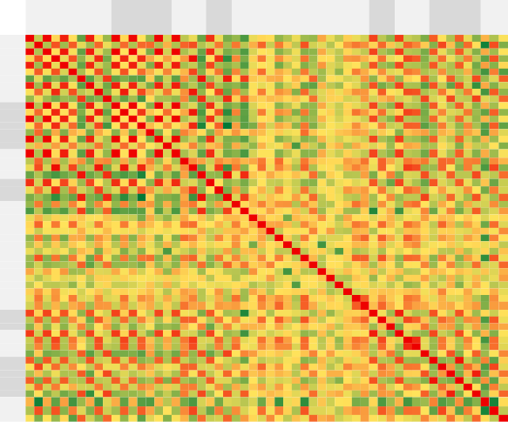

**Europe core**

**periphery Instr.**

**Europe Euro CH**

**Emerging Market**

**CA USA AU & NZ JP**

1 0 1 0 1 0 0 1 0 0 1 0 1 0 0 1 0 1 0 0 0 1 0 0 0 0 0 0 0 0 0 0 0 0 0 0 0 0 0 0 1 0 0 1 0 0 0 1 0 0 1 0 0 0 0 0

0 1 0 1 0 1 0 0 1 0 0 1 0 1 1 0 0 0 1 1 0 0 0 0 0 0 0 1 0 0 0 0 1 0 0 0 0 0 0 0 0 1 0 0 1 0 0 0 1 0 0 1 0 -1 1 0

1 0 1 0 1 0 0 1 0 0 1 0 1 0 0 1 0 1 0 0 0 1 0 0 0 0 0 0 0 0 0 0 0 0 0 0 0 0 0 0 1 0 0 1 0 0 0 1 0 0 1 0 0 0 0 0

0 1 0 1 0 1 0 0 1 0 0 1 0 1 0 0 0 0 0 1 0 0 1 0 0 0 0 0 0 0 0 0 1 0 0 0 0 0 0 0 0 1 0 0 1 1 0 0 1 0 0 0 0 0 1 0

1 0 1 0 1 0 0 1 0 0 1 0 1 0 0 1 0 1 0 0 0 1 0 0 0 0 0 0 0 0 0 0 0 0 0 0 0 0 0 0 1 0 0 1 0 0 0 1 0 0 1 0 0 0 0 0

0 1 0 1 0 1 0 0 1 0 0 1 0 1 0 0 0 0 0 1 0 0 1 0 0 0 0 1 0 0 0 0 0 0 0 0 0 0 0 0 0 0 0 0 1 0 0 0 0 0 0 0 0 0 0 0

0 0 0 0 0 0 1 0 0 1 0 0 0 0 0 0 0 0 0 0 1 0 0 1 0 1 0 0 0 0 0 0 0 1 0 0 0 0 0 0 0 0 0 0 0 0 1 0 0 1 0 0 1 0 0 1

1 0 1 0 1 0 0 1 0 0 1 0 1 0 0 1 0 1 0 0 0 1 0 0 0 0 0 0 0 0 0 0 0 0 0 0 0 0 0 0 1 0 0 1 0 0 0 1 0 0 1 0 0 0 0 0

0 1 0 1 0 1 0 0 1 0 0 1 0 1 0 0 1 0 0 1 0 0 1 0 0 0 0 0 0 0 0 0 1 0 0 0 0 0 0 0 0 1 0 0 1 1 0 0 1 0 0 0 0 0 1 0

0 0 0 0 0 0 1 0 0 1 0 0 0 0 0 0 0 0 0 0 1 0 0 1 0 1 0 0 0 0 0 0 0 1 0 0 0 0 0 0 0 0 0 0 0 0 1 0 0 1 0 0 1 0 0 1

1 0 1 0 1 0 0 1 0 0 1 0 1 0 0 1 0 1 0 0 0 1 0 0 0 0 0 0 0 0 0 0 0 0 0 0 0 0 0 0 1 0 0 1 0 0 0 1 0 0 1 0 0 0 0 0

0 1 0 1 0 1 0 0 1 0 0 1 0 1 0 0 1 0 0 1 0 0 1 0 0 0 0 0 0 0 0 0 0 0 0 0 0 0 1 0 0 1 0 0 1 1 0 0 0 0 0 0 0 0 1 0

1 0 1 0 1 0 0 1 0 0 1 0 1 0 0 1 0 1 0 0 0 1 0 0 0 0 0 0 0 0 0 0 0 0 0 0 0 0 0 0 1 0 0 1 0 0 0 1 0 0 1 0 0 0 0 0

0 1 0 1 0 1 0 0 1 0 0 1 0 1 0 0 0 0 0 1 -1 0 1 -1 0 0 0 0 0 0 0 0 1 0 0 0 0 0 0 0 0 0 0 0 1 1 0 0 0 0 0 0 0 0 1 0

0 1 0 0 0 0 0 0 0 0 0 0 0 0 1 0 0 0 0 0 0 0 0 0 0 0 0 0 0 0 0 0 1 0 0 0 0 0 0 0 0 0 0 0 0 0 0 0 0 0 0 0 0 0 0 0

1 0 1 0 1 0 0 1 0 0 1 0 1 0 0 1 0 1 0 0 0 1 0 0 0 0 0 0 0 0 0 0 0 0 0 0 0 0 0 0 1 0 0 1 0 0 0 1 0 0 1 0 0 0 0 0

0 0 0 0 0 0 0 0 1 0 0 1 0 0 0 0 1 0 0 0 0 0 0 0 0 0 0 0 0 0 0 0 0 0 0 0 0 0 0 0 0 0 0 0 0 0 0 0 0 0 0 0 0 0 0 0

1 0 1 0 1 0 0 1 0 0 1 0 1 0 0 1 0 1 0 0 0 1 0 0 0 0 0 0 0 0 0 0 0 0 0 0 0 0 0 0 1 0 0 1 0 0 0 1 0 0 1 0 0 0 0 0

0 1 0 0 0 0 0 0 0 0 0 0 0 0 0 0 0 0 1 0 0 0 0 0 0 0 0 0 0 1 0 0 0 0 0 0 0 0 0 1 0 1 0 0 0 0 0 0 1 1 0 0 0 0 0 0

0 1 0 1 0 1 0 0 1 0 0 1 0 1 0 0 0 0 0 1 0 0 1 0 0 0 0 1 0 0 0 0 1 0 0 0 0 0 0 0 0 1 0 0 1 1 0 0 1 0 0 0 0 0 1 0

0 0 0 0 0 0 1 0 0 1 0 0 0 -1 0 0 0 0 0 0 1 0 0 1 0 1 0 0 0 0 0 0 0 1 0 0 0 0 0 0 0 0 0 0 0 0 1 0 0 1 0 0 1 0 0 1

1 0 1 0 1 0 0 1 0 0 1 0 1 0 0 1 0 1 0 0 0 1 0 0 0 0 0 0 0 0 0 0 0 0 0 0 0 0 0 0 1 0 0 1 0 0 0 1 0 0 1 0 0 0 0 0

0 0 0 1 0 1 0 0 1 0 0 1 0 1 0 0 0 0 0 1 0 0 1 0 0 0 0 0 0 0 0 0 1 0 0 0 0 0 0 0 0 0 0 0 1 0 0 0 0 0 0 0 0 0 0 0

0 0 0 0 0 0 1 0 0 1 0 0 0 -1 0 0 0 0 0 0 1 0 0 1 0 1 0 0 0 0 0 0 0 1 0 0 0 0 0 0 0 0 0 0 0 0 1 0 0 1 0 0 1 0 0 1

0 0 0 0 0 0 0 0 0 0 0 0 0 0 0 0 0 0 0 0 0 0 0 0 1 0 0 0 0 0 0 0 0 0 0 0 0 0 1 0 0 0 0 0 0 1 0 0 0 0 0 0 0 0 0 0

0 0 0 0 0 0 1 0 0 1 0 0 0 0 0 0 0 0 0 0 1 0 0 1 0 1 0 0 0 0 0 0 0 0 0 0 0 0 0 0 0 0 0 0 0 0 0 0 0 0 0 0 1 0 0 0

0 0 0 0 0 0 0 0 0 0 0 0 0 0 0 0 0 0 0 0 0 0 0 0 0 0 1 0 0 0 0 0 0 0 0 0 0 0 0 0 0 0 0 0 0 0 0 0 0 0 0 0 0 0 0 0

0 1 0 0 0 1 0 0 0 0 0 0 0 0 0 0 0 0 0 1 0 0 0 0 0 0 0 1 0 0 0 0 0 0 0 0 0 0 1 0 0 1 0 0 1 0 0 0 1 0 0 0 0 0 1 0

0 0 0 0 0 0 0 0 0 0 0 0 0 0 0 0 0 0 0 0 0 0 0 0 0 0 0 0 1 0 0 0 0 0 0 0 0 0 0 0 0 0 0 0 0 0 0 0 0 0 0 0 0 0 0 0

0 0 0 0 0 0 0 0 0 0 0 0 0 0 0 0 0 0 1 0 0 0 0 0 0 0 0 0 0 1 0 0 0 0 0 0 0 0 0 1 0 1 0 0 1 0 0 0 0 0 0 0 0 0 0 0

0 0 0 0 0 0 0 0 0 0 0 0 0 0 0 0 0 0 0 0 0 0 0 0 0 0 0 0 0 0 1 0 0 0 0 0 0 0 0 0 0 0 0 0 0 0 0 0 0 0 0 0 0 0 0 0

0 0 0 0 0 0 0 0 0 0 0 0 0 0 0 0 0 0 0 0 0 0 0 0 0 0 0 0 0 0 0 1 0 0 0 0 0 0 0 0 0 0 0 0 0 0 0 0 0 0 0 0 0 0 0 0

0 1 0 1 0 0 0 0 1 0 0 0 0 1 1 0 0 0 0 1 0 0 1 0 0 0 0 0 0 0 0 0 1 0 0 0 0 0 1 1 0 1 0 0 1 1 0 0 0 0 0 0 0 0 1 0

0 0 0 0 0 0 1 0 0 1 0 0 0 0 0 0 0 0 0 0 1 0 0 1 0 0 0 0 0 0 0 0 0 1 0 0 0 0 0 0 0 0 0 0 0 0 0 0 0 0 0 0 1 0 0 1

0 0 0 0 0 0 0 0 0 0 0 0 0 0 0 0 0 0 0 0 0 0 0 0 0 0 0 0 0 0 0 0 0 0 1 0 0 0 0 0 0 0 0 0 0 0 0 0 0 0 0 0 0 0 0 0

0 0 0 0 0 0 0 0 0 0 0 0 0 0 0 0 0 0 0 0 0 0 0 0 0 0 0 0 0 0 0 0 0 0 0 1 0 0 0 0 0 0 0 0 0 0 0 0 0 0 0 0 0 0 0 0

0 0 0 0 0 0 0 0 0 0 0 0 0 0 0 0 0 0 0 0 0 0 0 0 0 0 0 0 0 0 0 0 0 0 0 0 1 0 0 0 0 0 0 0 0 0 0 0 0 0 0 0 0 0 0 0

0 0 0 0 0 0 0 0 0 0 0 0 0 0 0 0 0 0 0 0 0 0 0 0 0 0 0 0 0 0 0 0 0 0 0 0 0 1 0 0 0 0 0 0 0 0 0 0 0 0 0 0 0 0 0 0

0 0 0 0 0 0 0 0 0 0 0 1 0 0 0 0 0 0 0 0 0 0 0 0 1 0 0 1 0 0 0 0 1 0 0 0 0 0 1 1 0 0 0 0 1 0 0 0 0 0 0 0 0 0 0 0

0 0 0 0 0 0 0 0 0 0 0 0 0 0 0 0 0 0 1 0 0 0 0 0 0 0 0 0 0 1 0 0 1 0 0 0 0 0 1 1 0 1 0 0 0 0 0 0 0 0 0 0 0 0 0 0

1 0 1 0 1 0 0 1 0 0 1 0 1 0 0 1 0 1 0 0 0 1 0 0 0 0 0 0 0 0 0 0 0 0 0 0 0 0 0 0 1 0 0 1 0 0 0 1 0 0 1 0 0 0 0 0

0 1 0 1 0 0 0 0 1 0 0 1 0 0 0 0 0 0 1 1 0 0 0 0 0 0 0 1 0 1 0 0 1 0 0 0 0 0 0 1 0 1 0 0 1 1 0 0 1 0 0 0 0 0 1 0

0 0 0 0 0 0 0 0 0 0 0 0 0 0 0 0 0 0 0 0 0 0 0 0 0 0 0 0 0 0 0 0 0 0 0 0 0 0 0 0 0 0 1 0 0 0 1 0 0 0 0 0 0 0 0 0

1 0 1 0 1 0 0 1 0 0 1 0 1 0 0 1 0 1 0 0 0 1 0 0 0 0 0 0 0 0 0 0 0 0 0 0 0 0 0 0 1 0 0 1 0 0 0 1 0 0 1 0 0 0 0 0

0 1 0 1 0 1 0 0 1 0 0 1 0 1 0 0 0 0 0 1 0 0 1 0 0 0 0 1 0 1 0 0 1 0 0 0 0 0 1 0 0 1 0 0 1 1 0 0 1 0 0 0 0 0 1 0

0 0 0 1 0 0 0 0 1 0 0 1 0 1 0 0 0 0 0 1 0 0 0 0 1 0 0 0 0 0 0 0 1 0 0 0 0 0 0 0 0 1 0 0 1 1 0 0 0 0 0 0 0 0 1 0

0 0 0 0 0 0 1 0 0 1 0 0 0 0 0 0 0 0 0 0 1 0 0 1 0 0 0 0 0 0 0 0 0 0 0 0 0 0 0 0 0 0 1 0 0 0 1 0 0 1 0 0 1 0 0 0

1 0 1 0 1 0 0 1 0 0 1 0 1 0 0 1 0 1 0 0 0 1 0 0 0 0 0 0 0 0 0 0 0 0 0 0 0 0 0 0 1 0 0 1 0 0 0 1 0 0 1 0 0 0 0 0

0 1 0 1 0 0 0 0 1 0 0 0 0 0 0 0 0 0 1 1 0 0 0 0 0 0 0 1 0 0 0 0 0 0 0 0 0 0 0 0 0 1 0 0 1 0 0 0 1 0 0 1 0 0 1 0

0 0 0 0 0 0 1 0 0 1 0 0 0 0 0 0 0 0 1 0 1 0 0 1 0 0 0 0 0 0 0 0 0 0 0 0 0 0 0 0 0 0 0 0 0 0 1 0 0 1 0 0 1 0 0 1

1 0 1 0 1 0 0 1 0 0 1 0 1 0 0 1 0 1 0 0 0 1 0 0 0 0 0 0 0 0 0 0 0 0 0 0 0 0 0 0 1 0 0 1 0 0 0 1 0 0 1 0 0 0 0 0

0 1 0 0 0 0 0 0 0 0 0 0 0 0 0 0 0 0 0 0 0 0 0 0 0 0 0 0 0 0 0 0 0 0 0 0 0 0 0 0 0 0 0 0 0 0 0 0 1 0 0 1 0 0 0 0

0 0 0 0 0 0 1 0 0 1 0 0 0 0 0 0 0 0 0 0 1 0 0 1 0 1 0 0 0 0 0 0 0 1 0 0 0 0 0 0 0 0 0 0 0 0 1 0 0 1 0 0 1 0 0 1

0 -1 0 0 0 0 0 0 0 0 0 0 0 0 0 0 0 0 0 0 0 0 0 0 0 0 0 0 0 0 0 0 0 0 0 0 0 0 0 0 0 0 0 0 0 0 0 0 0 0 0 0 0 1 -1 0

0 1 0 1 0 0 0 0 1 0 0 1 0 1 0 0 0 0 0 1 0 0 0 0 0 0 0 1 0 0 0 0 1 0 0 0 0 0 0 0 0 1 0 0 1 1 0 0 1 0 0 0 0 -1 1 0

0 0 0 0 0 0 1 0 0 1 0 0 0 0 0 0 0 0 0 0 1 0 0 1 0 0 0 0 0 0 0 0 0 1 0 0 0 0 0 0 0 0 0 0 0 0 0 0 0 1 0 0 1 0 0 1

**EM**

**Bon**

**Equity**

**Bonds**

**Credit**

**JP USA CA Emerging Market CH Euro Europe Europe core**

**Instr. peripher**

Correlation coefficient colour scale



Sources: Bloomberg and Bank calculations.

(a) Correlation matrices are based on correlation matrices developed by HSBC FX Quantitative Strategy Team. Data refer to correlation of weekly returns measured over a backward-looking one-year period. Quotation conventions for prices and yields have been normalised onto a price-based quotation convention so that a positive correlation denotes equity prices going up and bond prices going up for example (hence yields and spreads dropping). The VIX has been normalised like a yield, so that VIX going down with equity prices rising produces positive correlation.

|  |  |
| --- | --- |
| **Chart 19: Cross-border bank claims on all sectors(a)**  Percent change on a 5  quarter earlier  4  3  2  1  0  -1  25/75 Interquartile range  Average -2  Mov. Average (4 quarters)  -3  1995 1998 2001 2004 2007 2010  Source: BIS and Bank calculations.  (a) Data cover international financial claims and liabilities of bank offices resident in 46 countries. Nominal series (in US dollars) have  been deflated with a measure of US CPI. | **Chart 20: Total credit to the private sector(a)**  Percent change on 15  a quarter earlier  12  9  6  3  0  -3  -6  25/75 Interquartile range  Average -9  Mov. Average (4 quarters)  -12  1995 1998 2001 2004 2007 2010  Source: BIS and Bank calculations.  (a) Data cover loans and debt securities for 35 countries between 1995 and 2012. Nominal series (in local currency) have been  deflated with a measure of domestic CPI. |

# Table 1: Composition of capital flows, 1980-2012

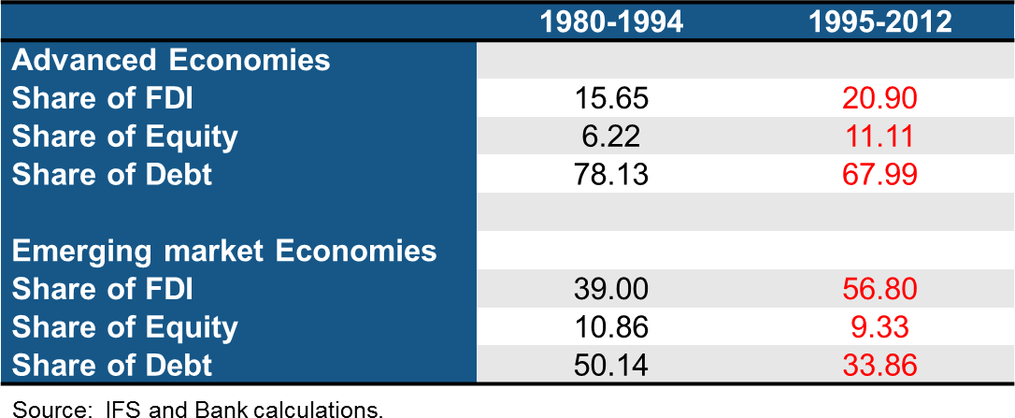

**Table 2: Average pairwise correlation in cross-border bank claims across countries**

|  |  |  |
| --- | --- | --- |
| Cross-border bank claims | | |
|  | 1995-2003 | 2003-2012 |
| Level | 0.45 | 0.67 |
| Quarterly growth | 0.03 | 0.17 |

Source: BIS and Bank calculations.

(a) Data cover international financial claims and liabilities of bank offices resident in 46 countries. Nominal series (in US dollars) have been deflated with a measure of US CPI.

# Table 3: Average pairwise correlation in total credit across countries(a)

|  |  |  |
| --- | --- | --- |
|  | Total credit |  |
|  | 1995-2003 | 2003-2012 |
| Level | 0.12 | 0.45 |
| Quarterly Growth | 0.11 | 0.29 |

Source: BIS and Bank calculations.

(a) The data cover loans and debt securities for 35 countries between 1995 and 2012. Nominal series (in local currency) have been deflated with a measure of domestic CPI.